1. **Install Windows Server**

* Set an IP address and DNS addresses (Conestoga DNS Servers) in your COM port range

🡪**Ashah5540 (Com port range 172.16.214.0/24)**

* Set a relevant hostname ex. Lastname-DC1

🡪**Shah-DC1**

Installing new VM with name Shah-DC1

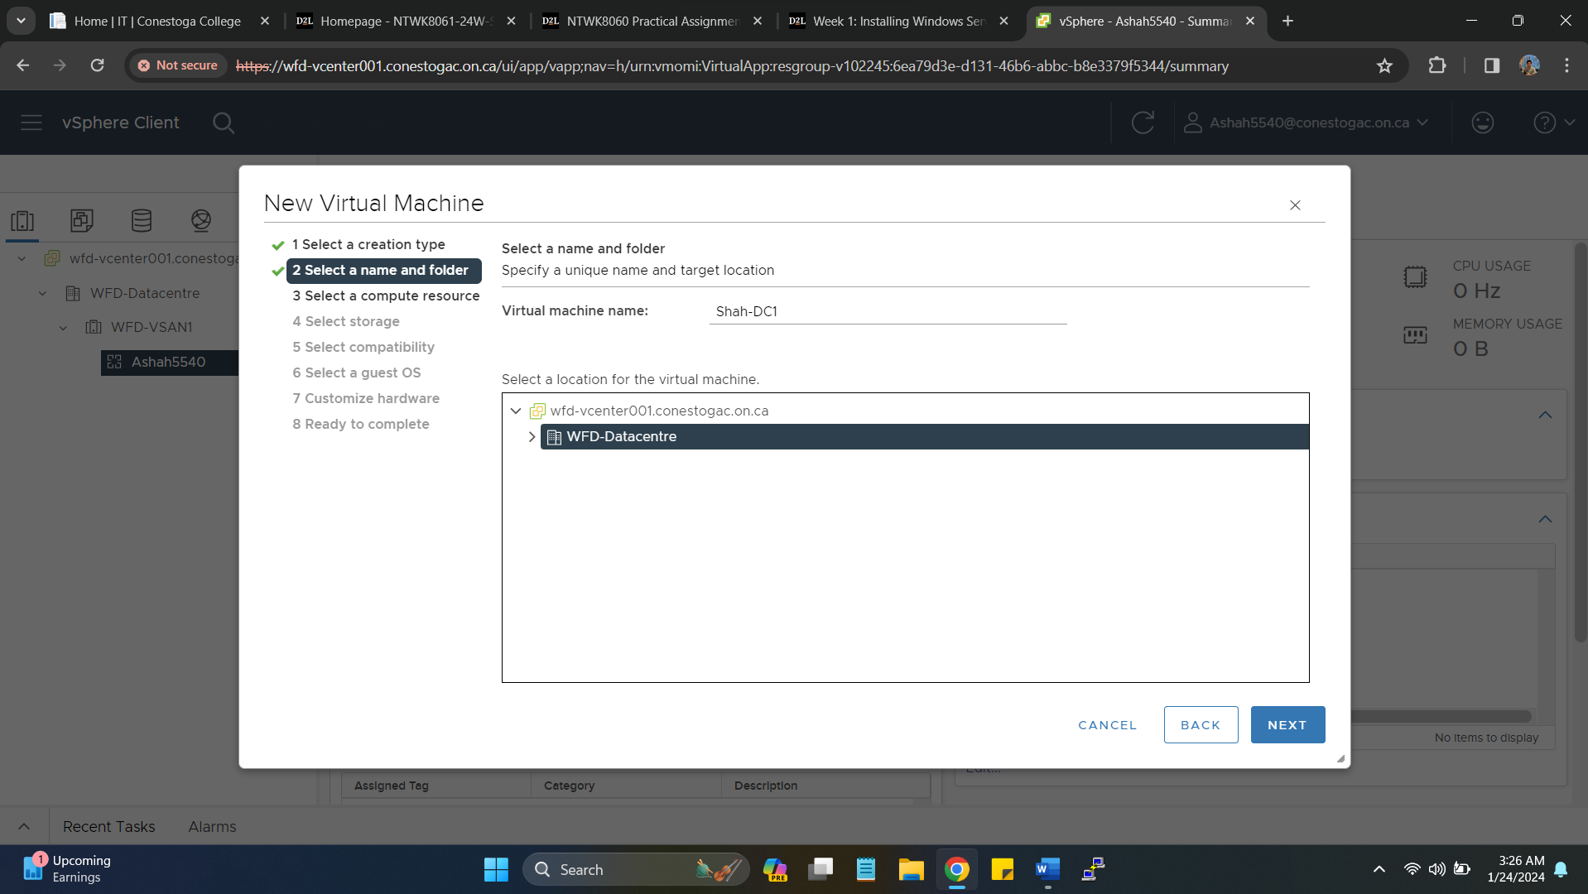

Selecting ESXi 7.0 U2 or later for compatibility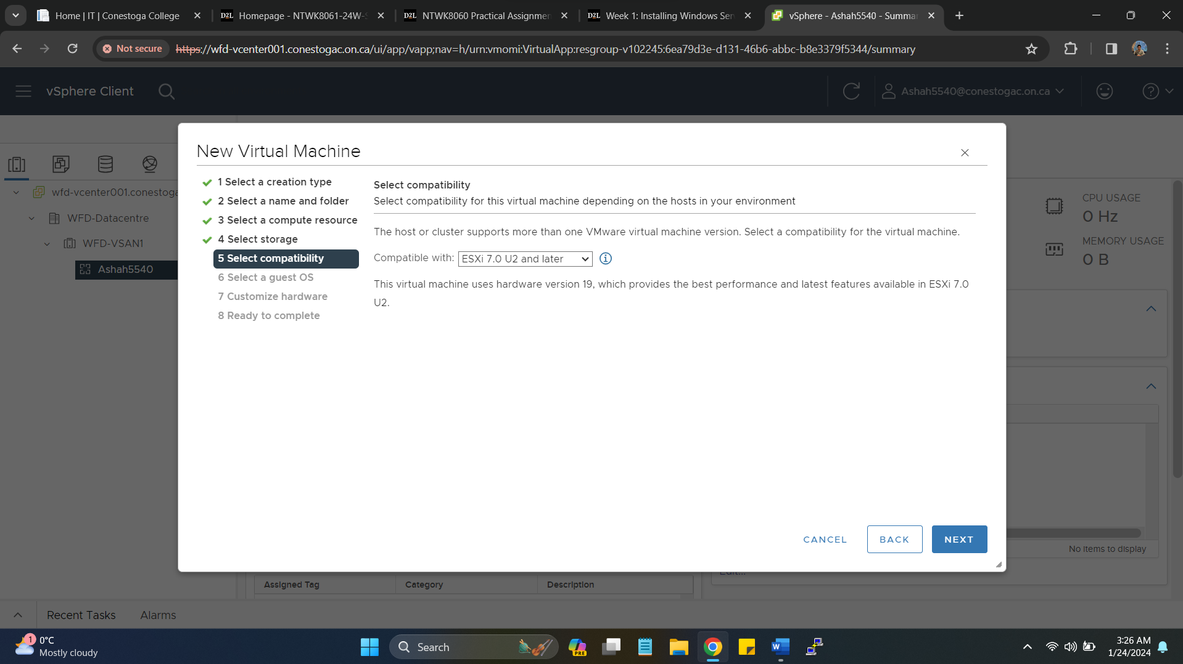

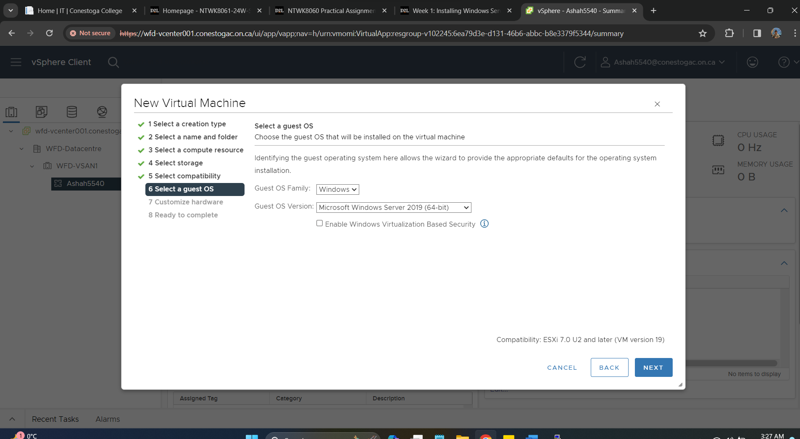

Selecting COM Port range 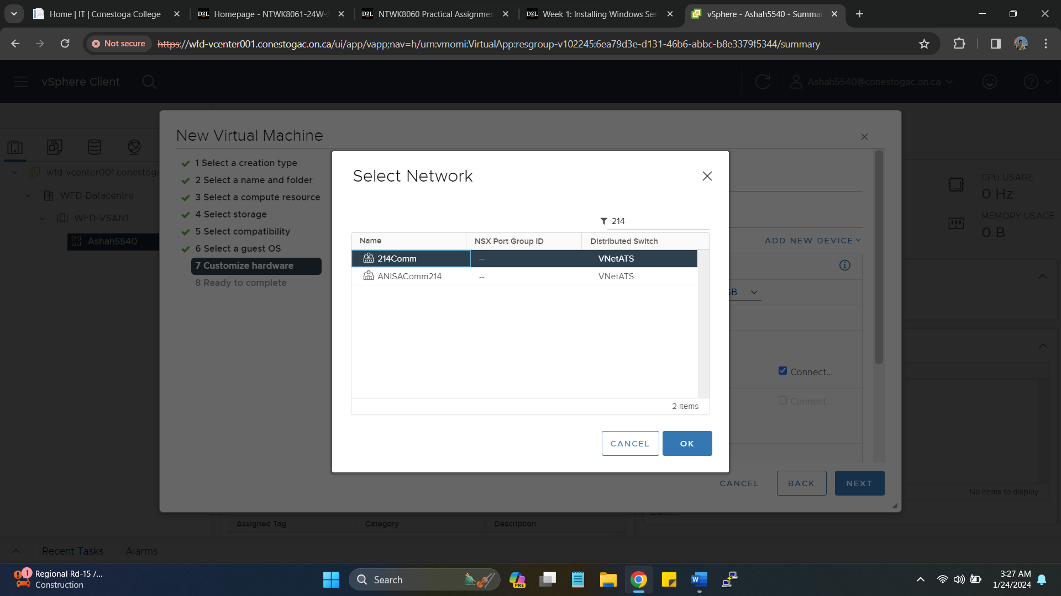

Virtual Machine Installation Summary for Domain Controller 1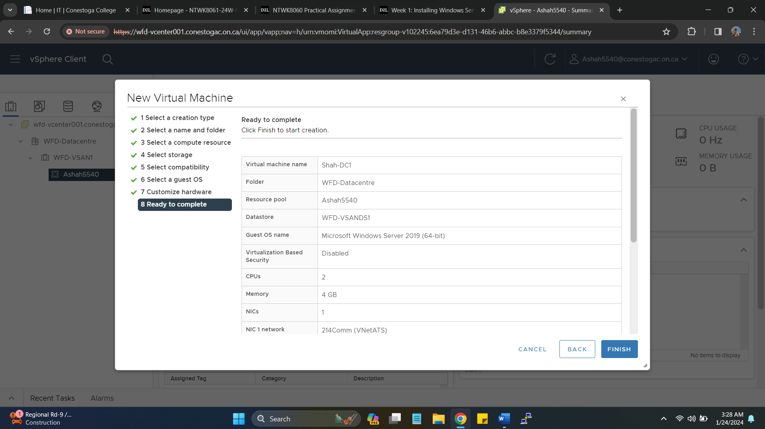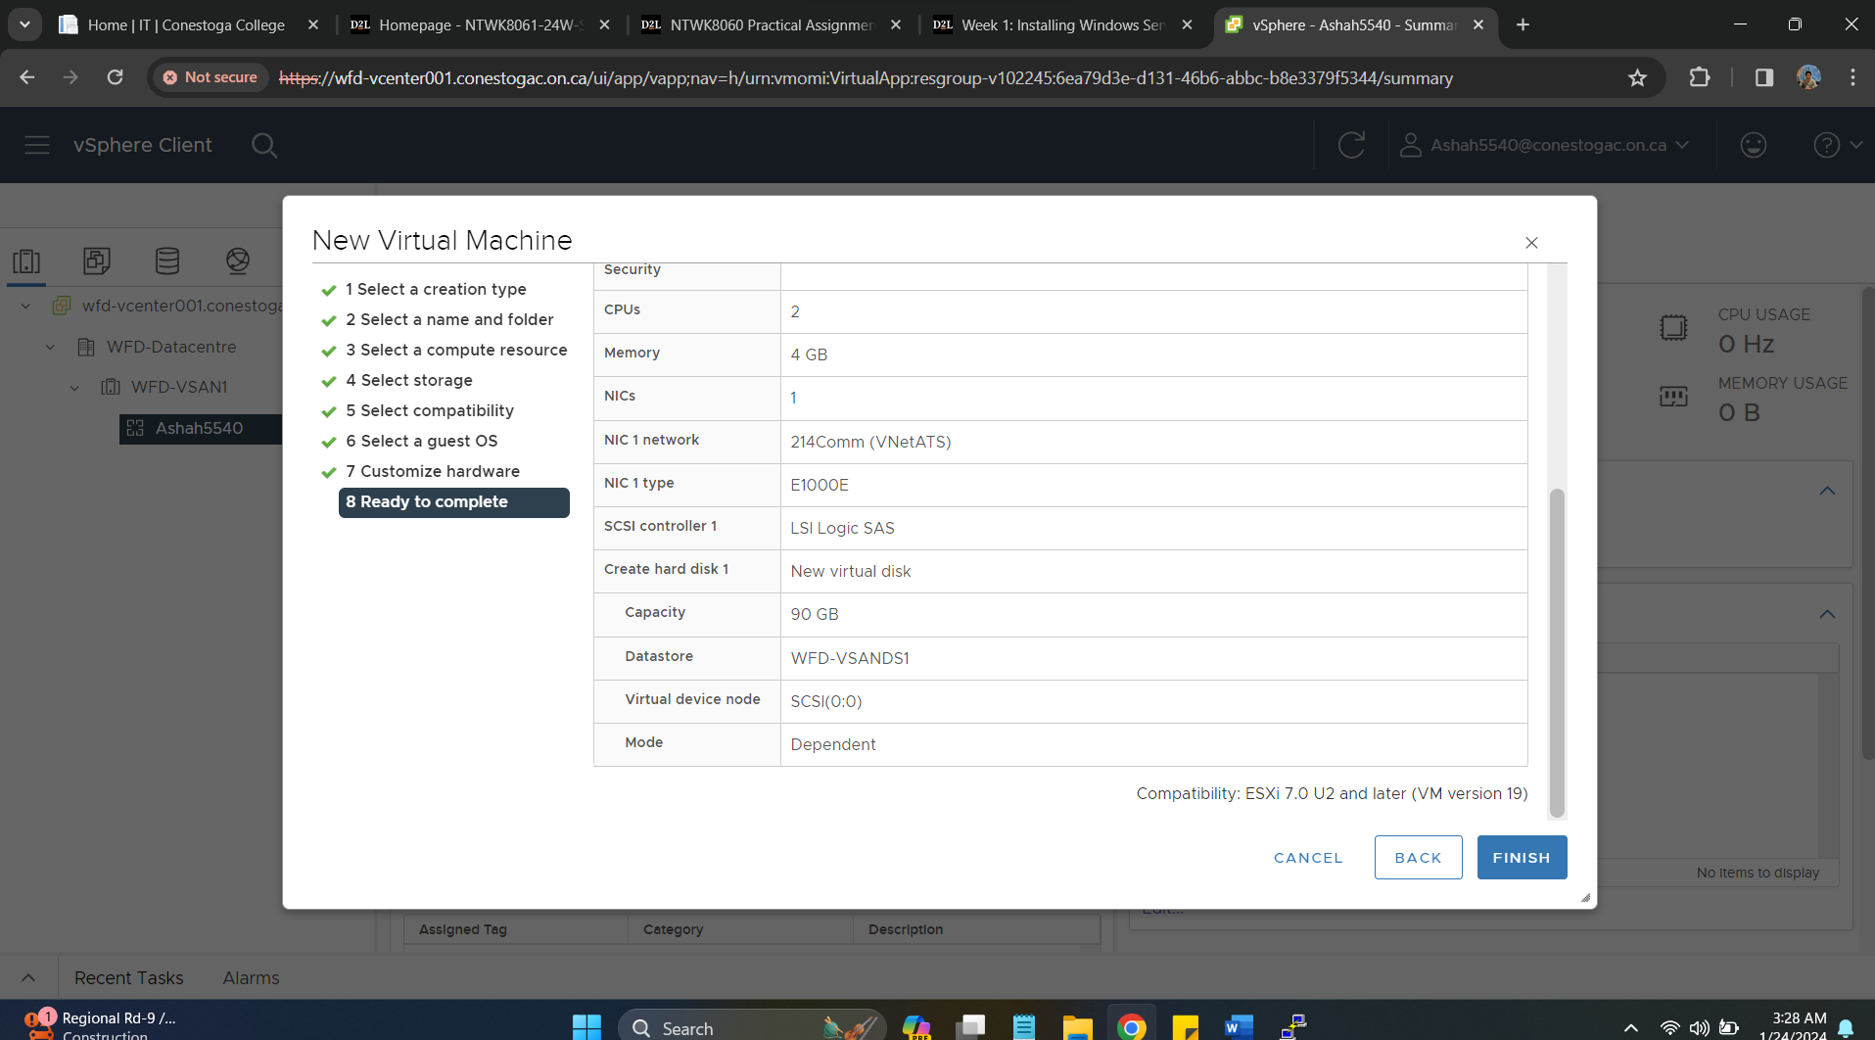

Selecting Operating System Windows Server 2019 to Load on Virtual Machine for Domain Controller DC1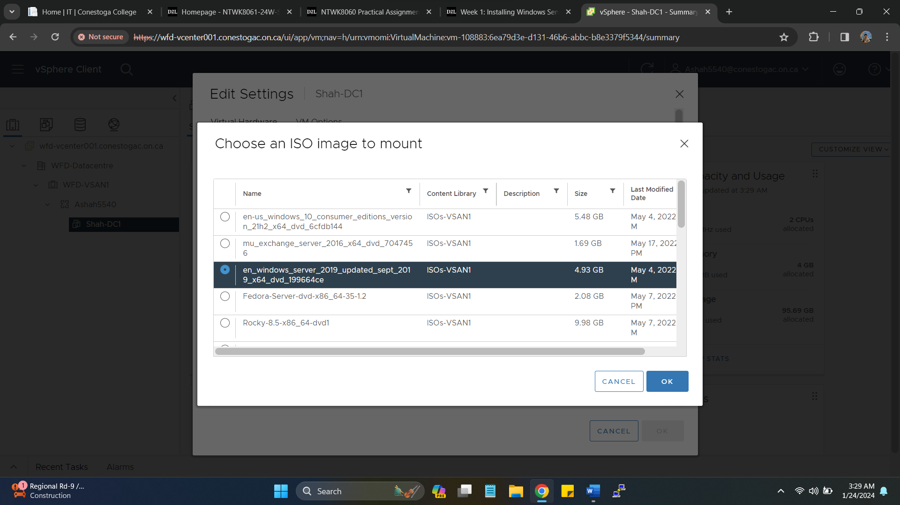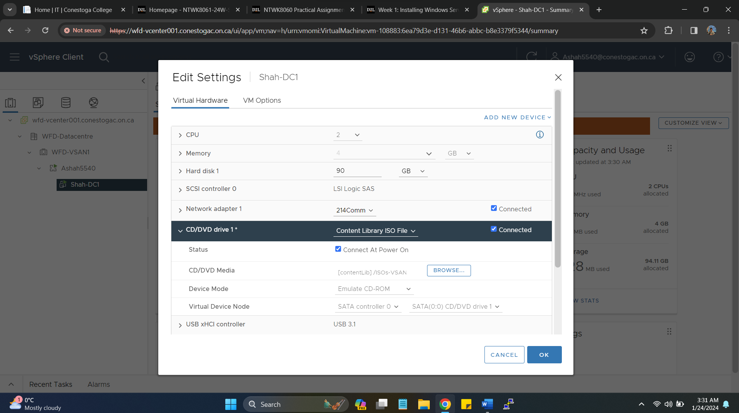

Installing Windows Server 2019 Standard Desktop Experience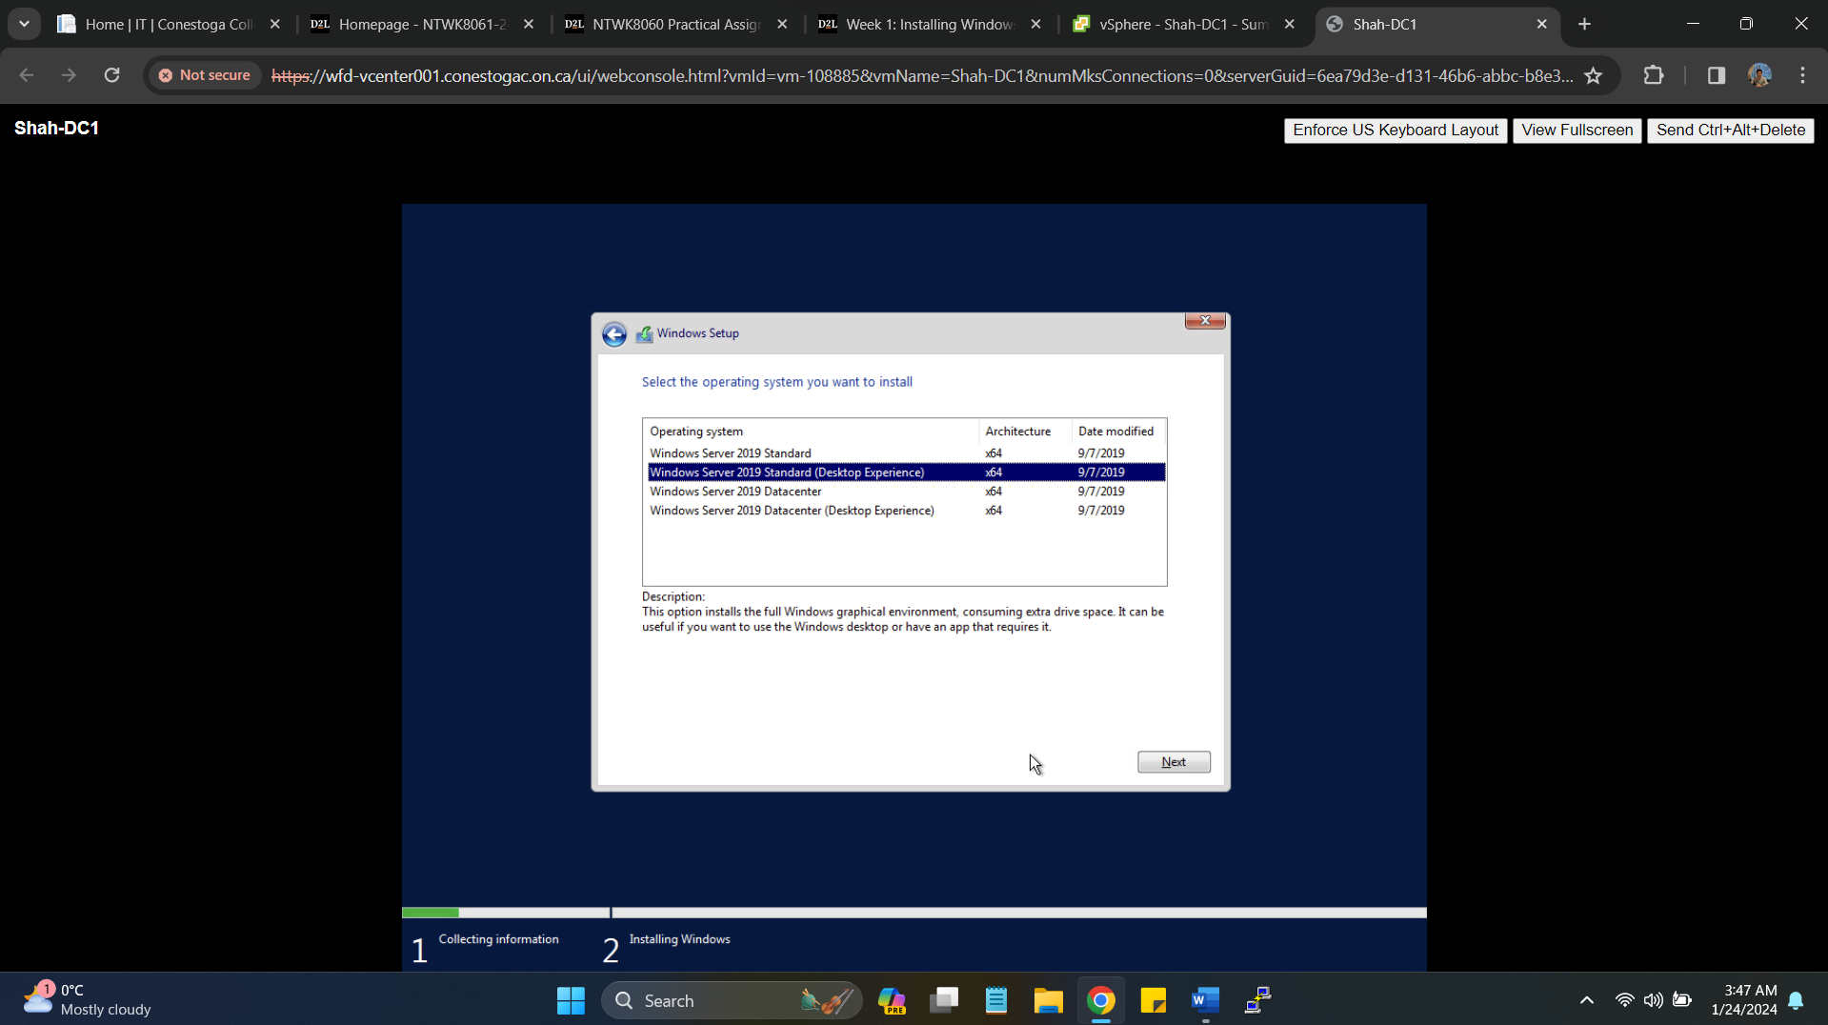

Providing Password as **Secret55**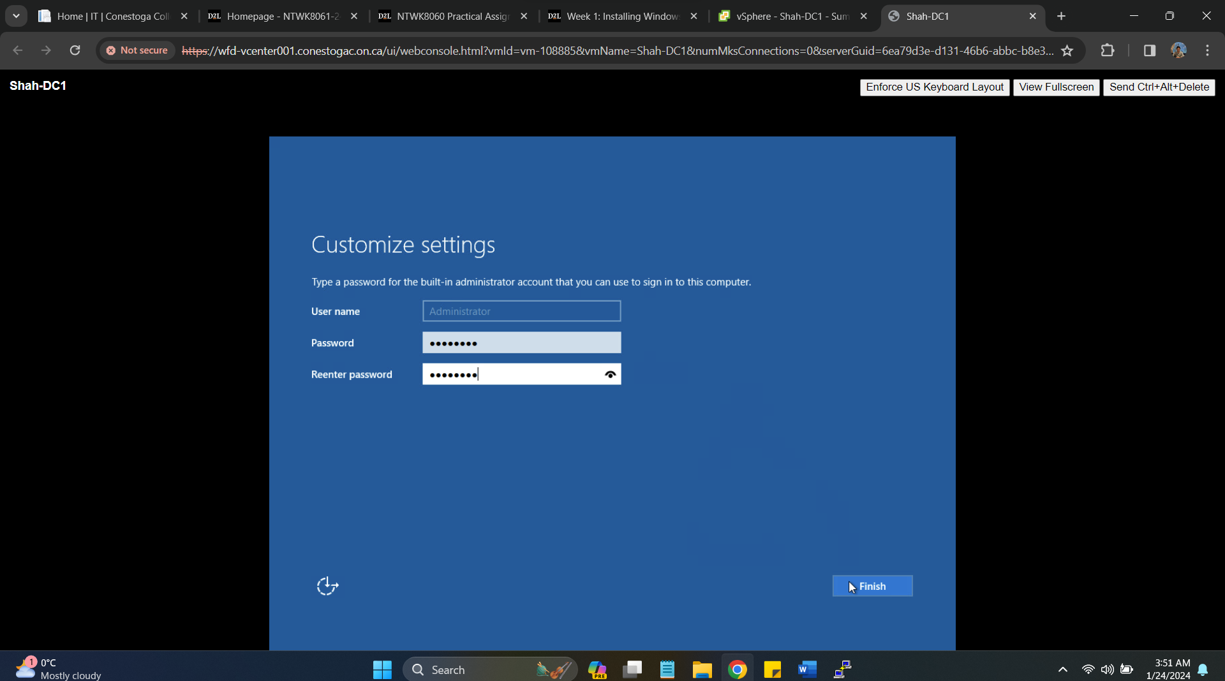

**Installing VMtools on DC1 Server**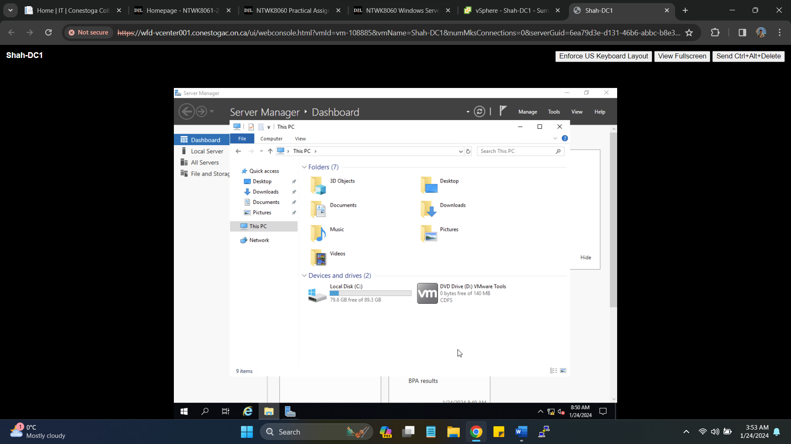

**Successfully installation completion of VMtools**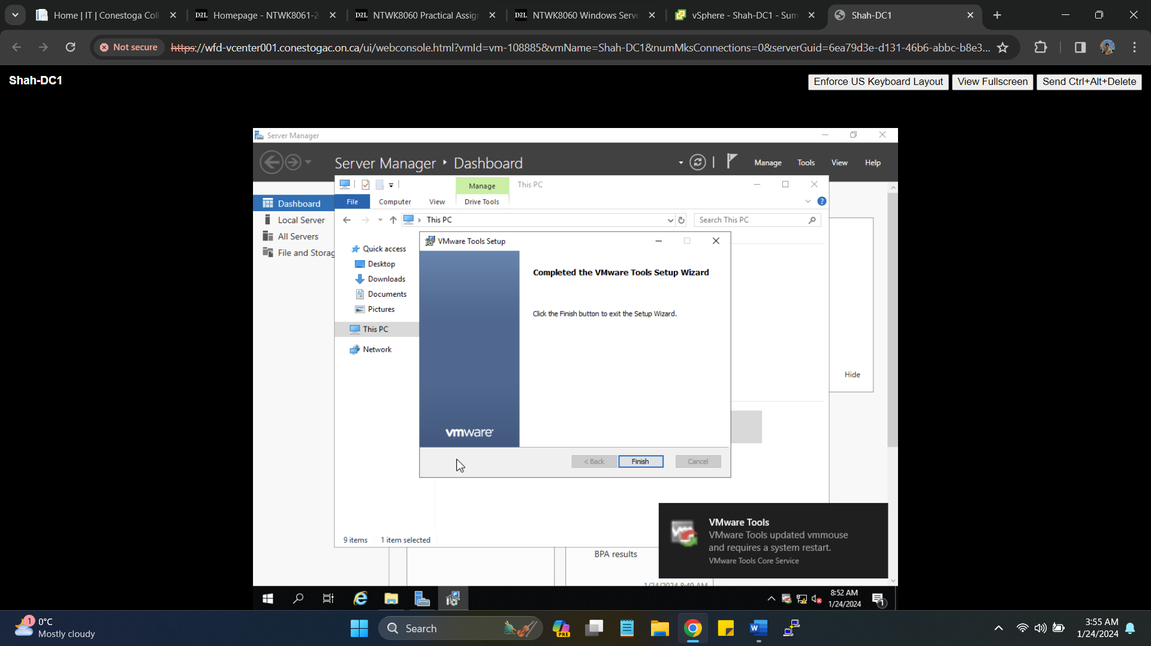

**Changing IPv4 settings and providing DNS IP as primary and secondary**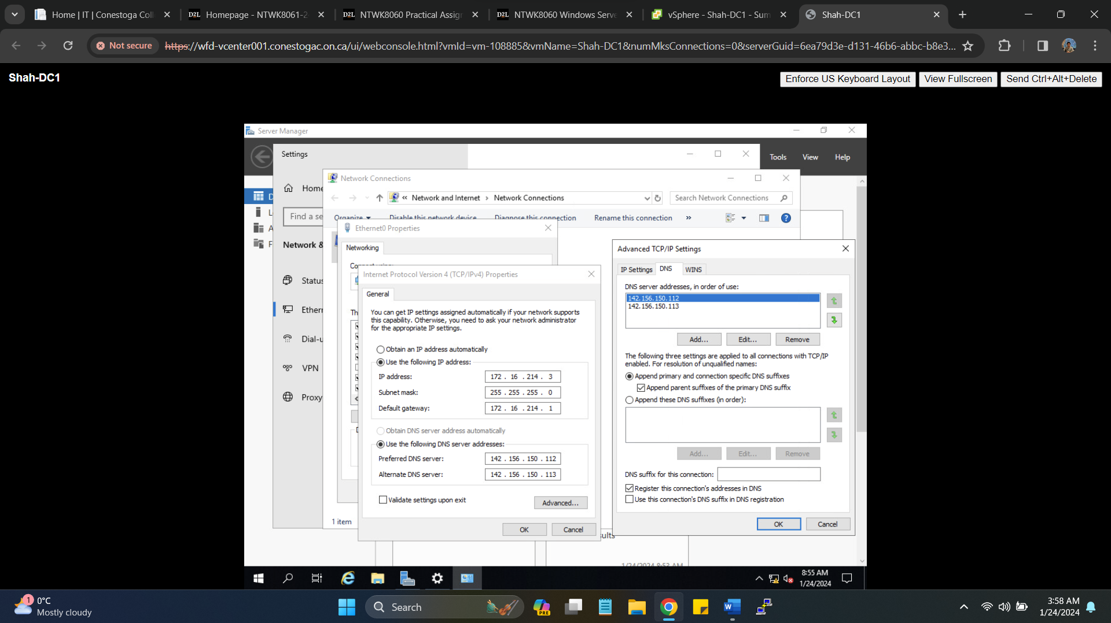

Changing Server Name and Domain details, further restart mandatory to reflect changes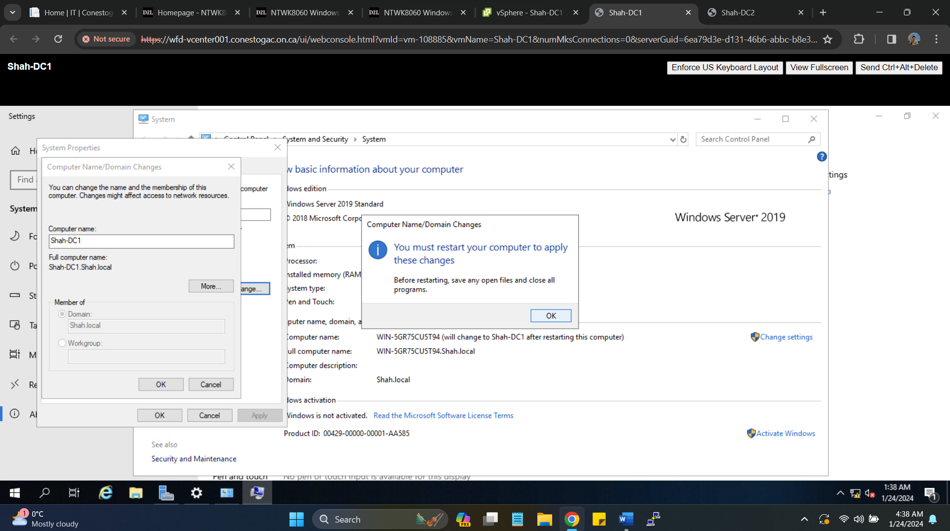Domain Name and Server DC1 name changes done successfully.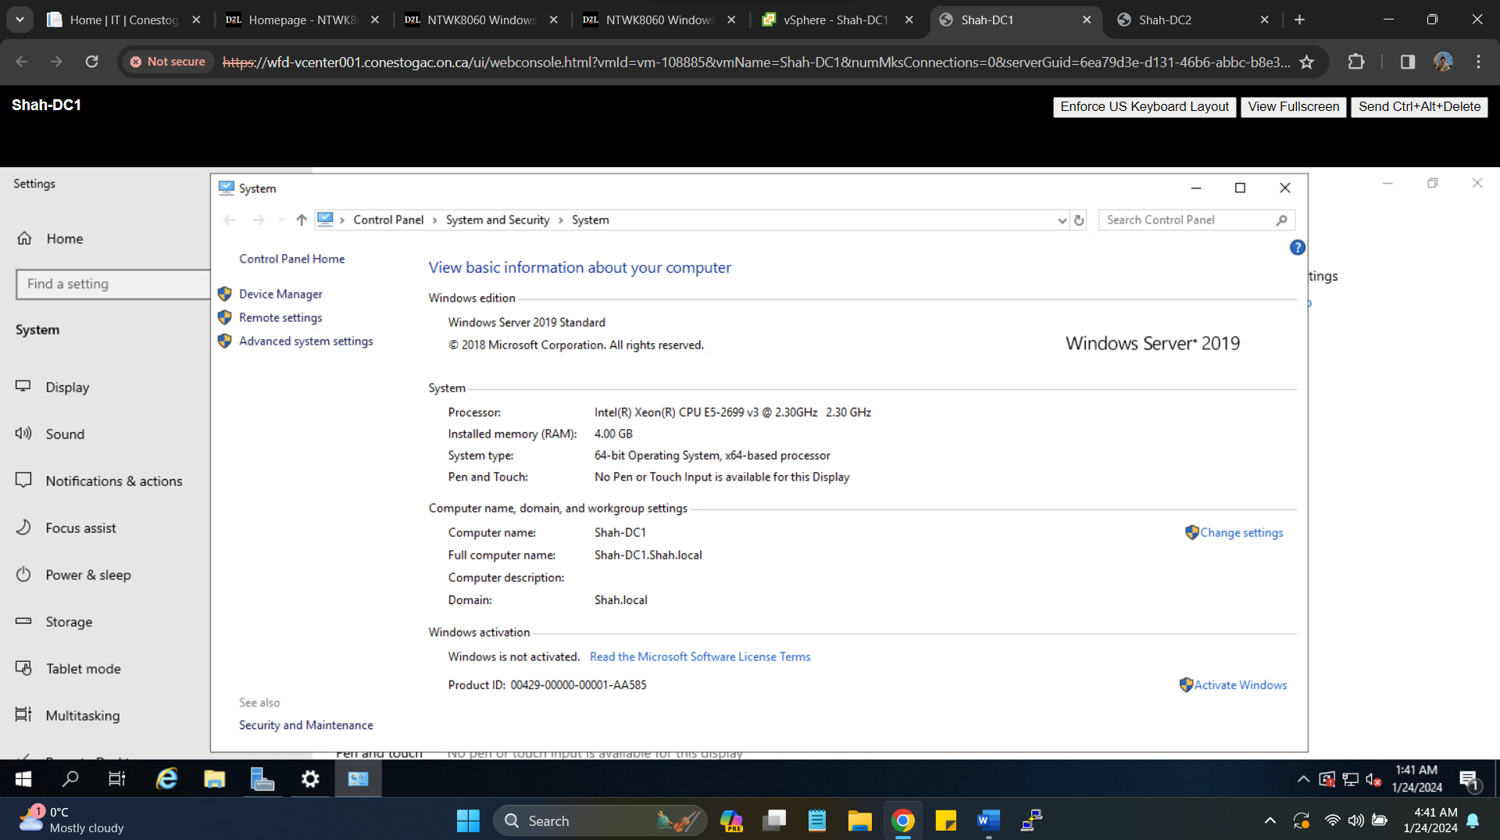

1. **Promote Windows Server to an Active Directory Domain Controller**

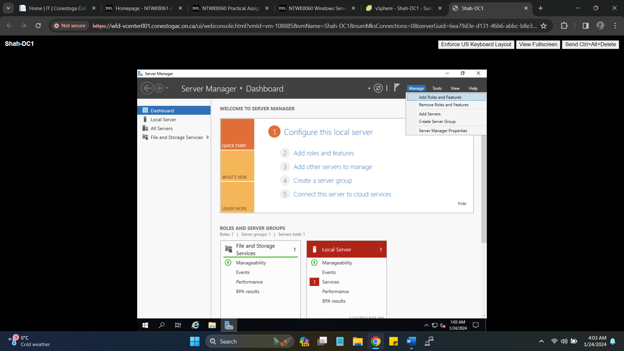

Selecting Roles and features to install on Primary DC-1 Domain Controller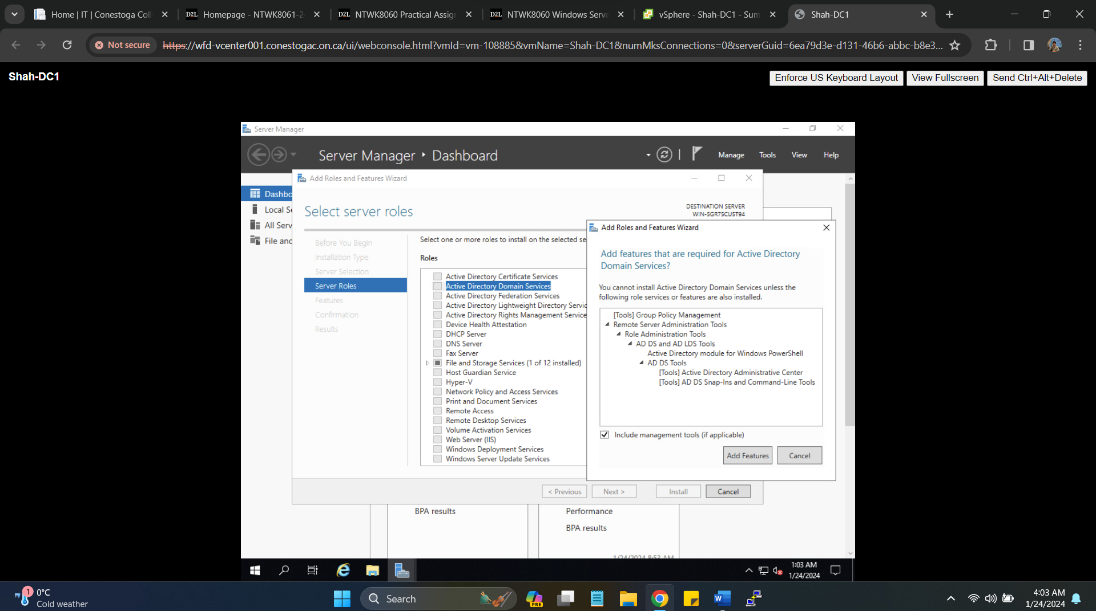

Successful installation of ADDS on DC-1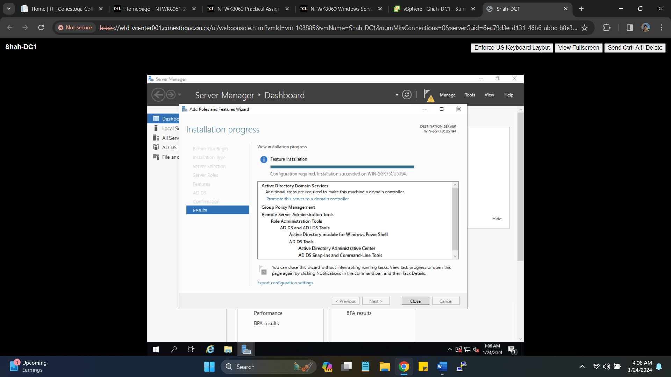

Promoting server to Domain Controller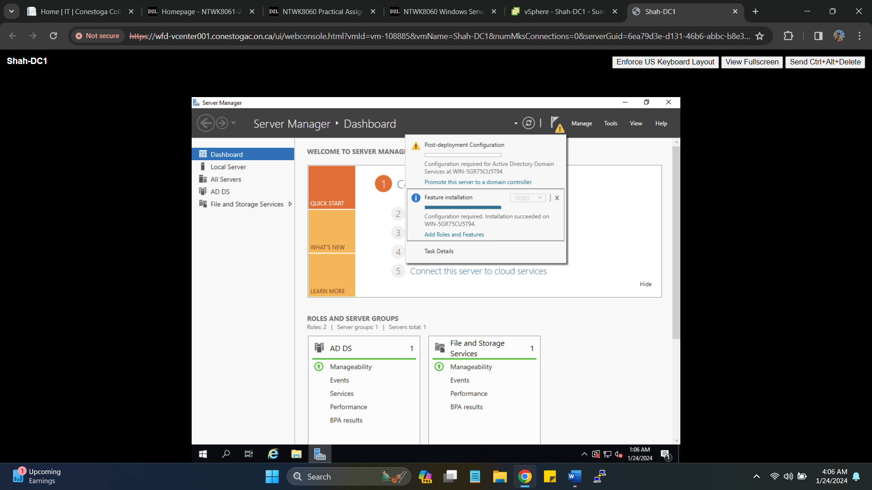Providing Domain name (**Shah.local**) and creating a new forest for the first time. 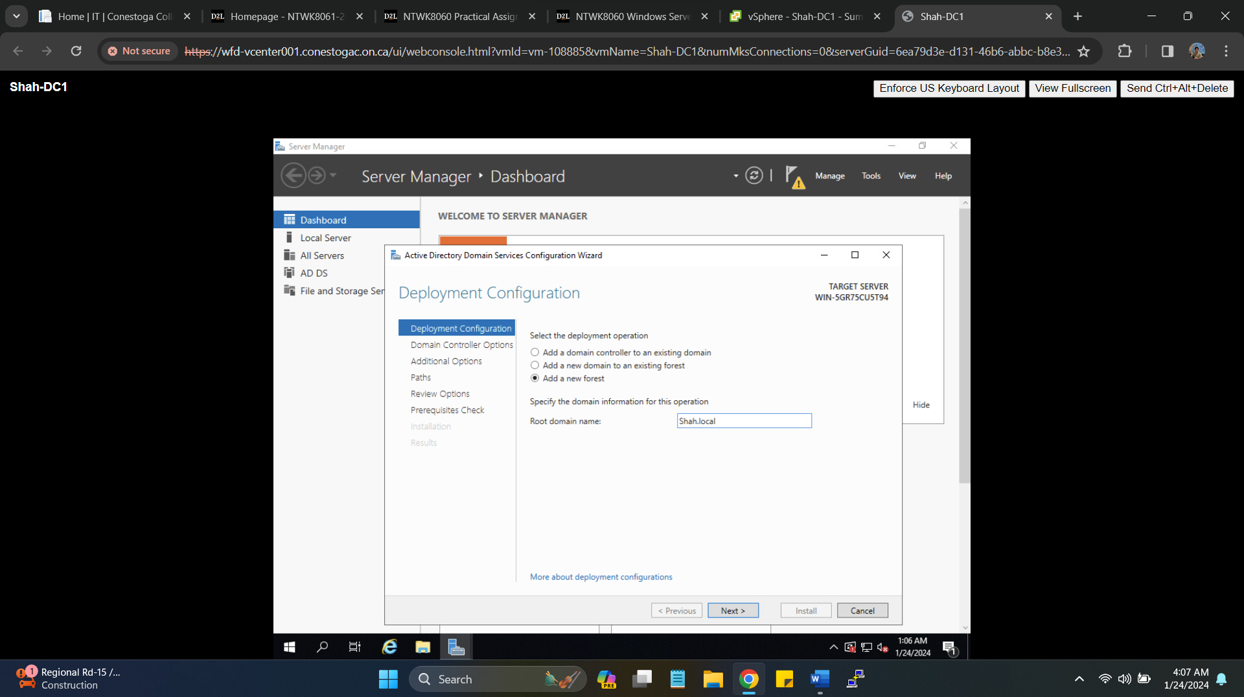Providing Password as Secret55 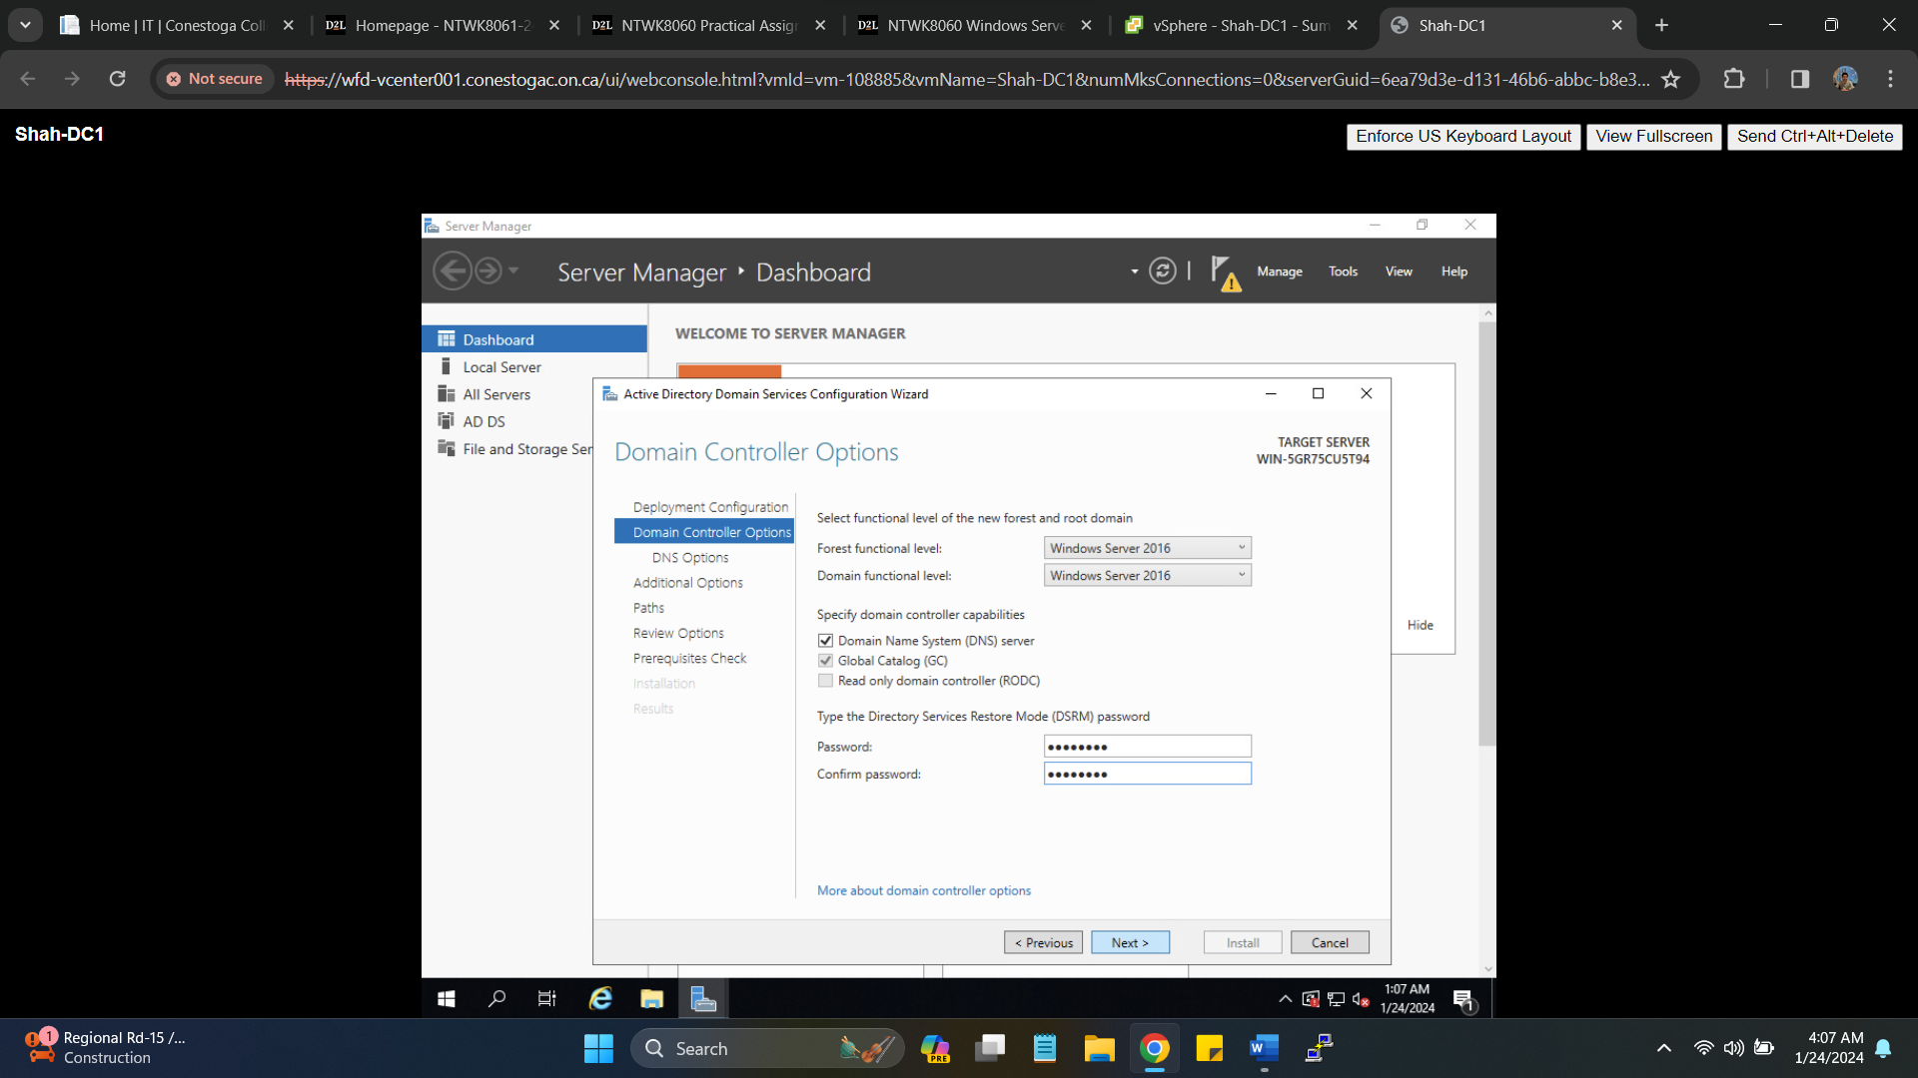Successful installation of ADDS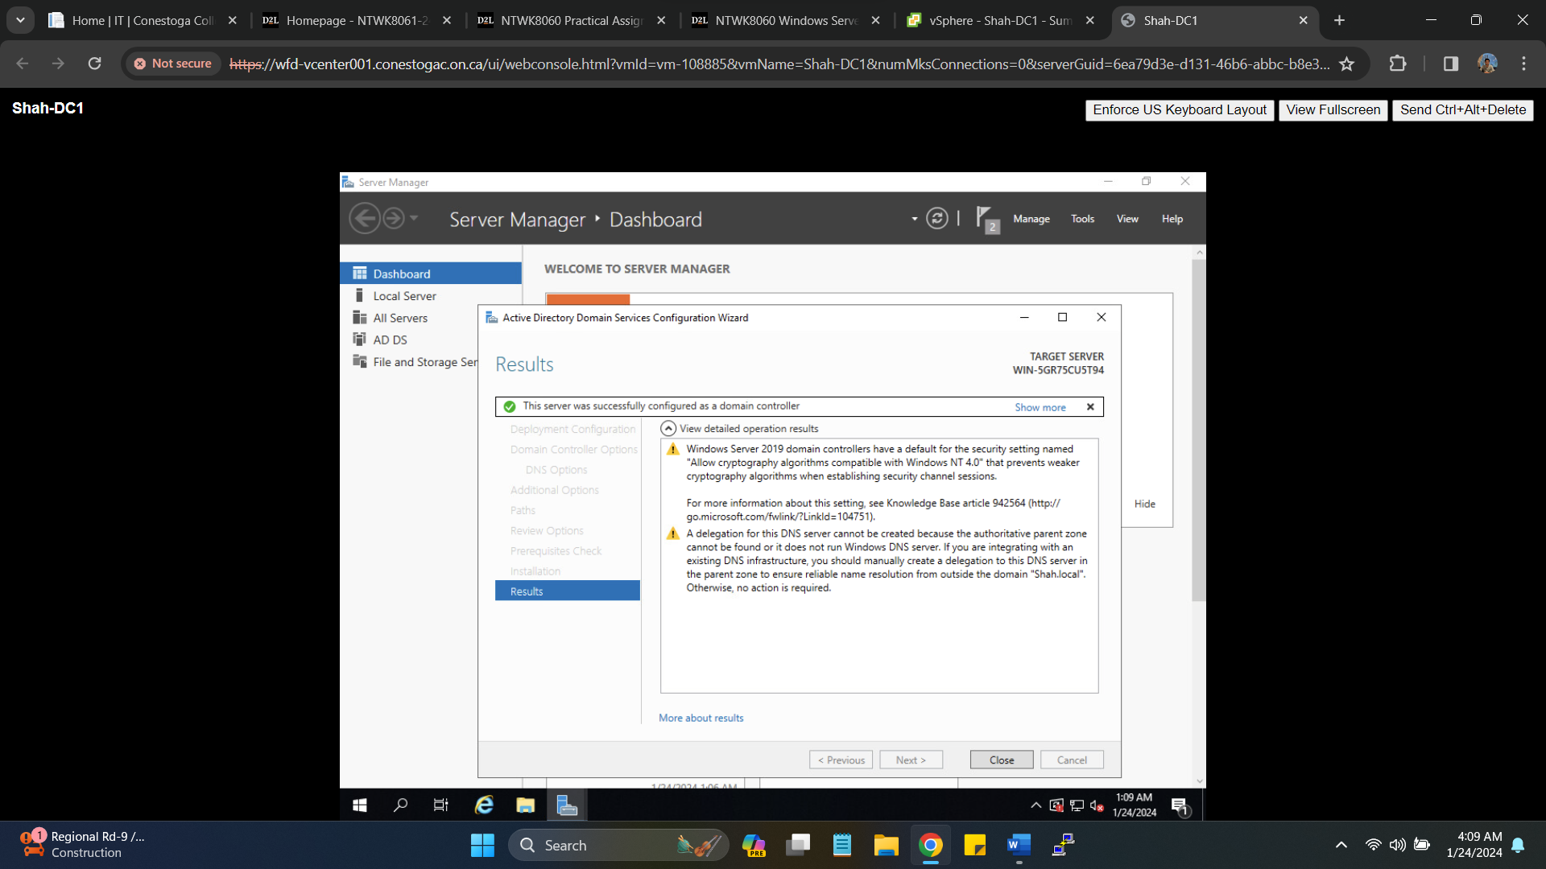

Administrator Logging with Domain 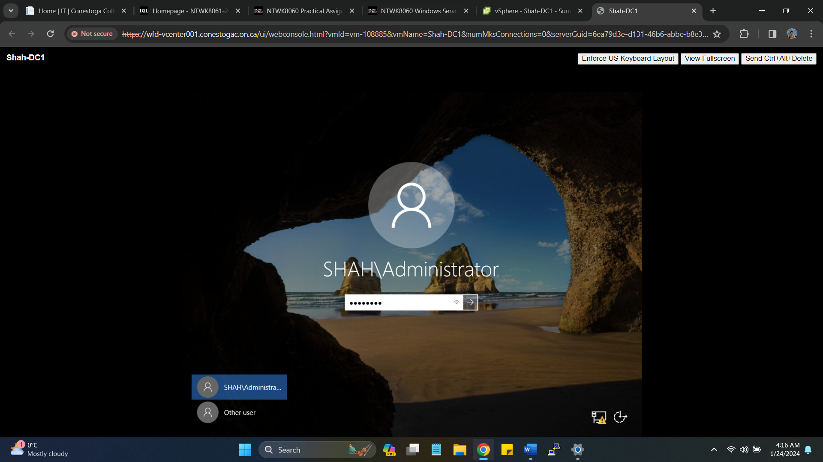

1. **Install a second Windows Server and promote it as a Secondary Domain Controller in your domain**

* Set an IP address and DNS address (pointing to your DC1) in your COM port range

DC-1 IP address: **172.16.214.3**

Gateway: **172.16.214.1**

Creating new VM for DC-2 name as **Shah-DC2**

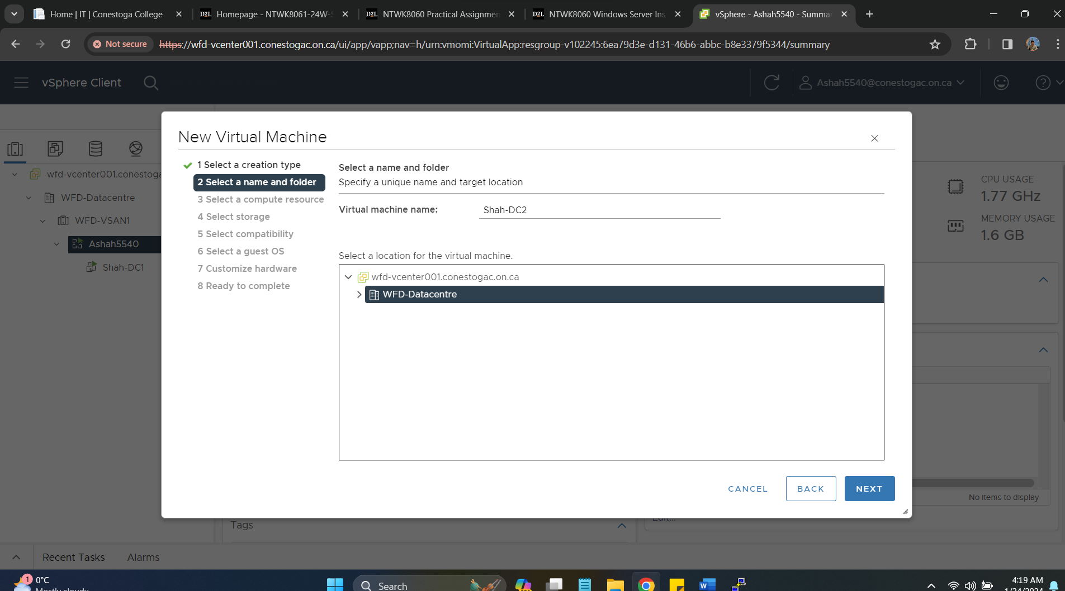

Using COM port range for Ashah5540 (214)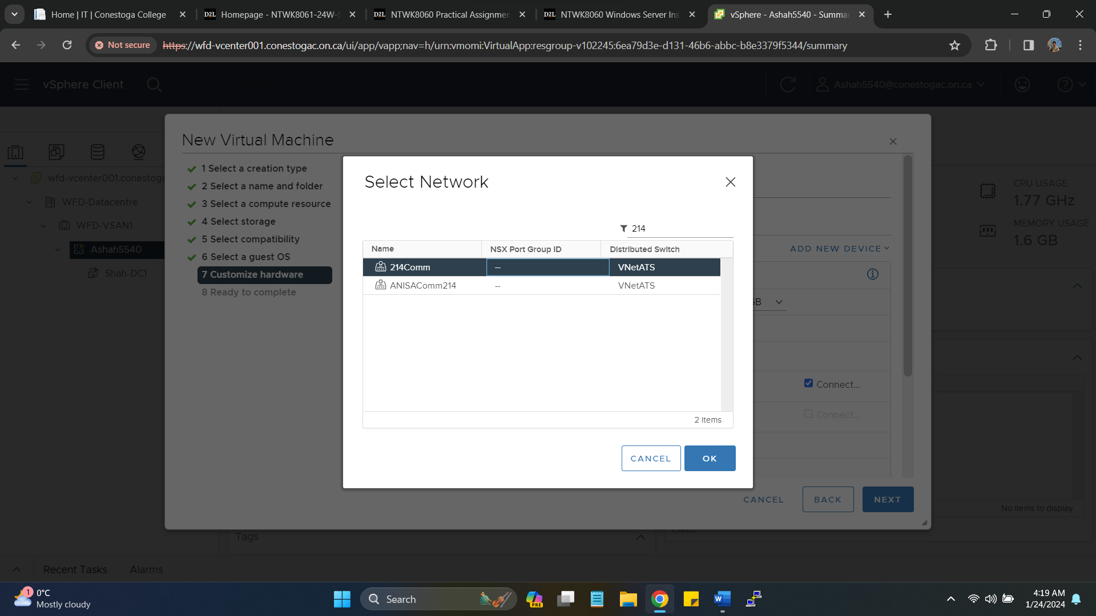

Selecting Windows Server 2019 operating for DC-2 installation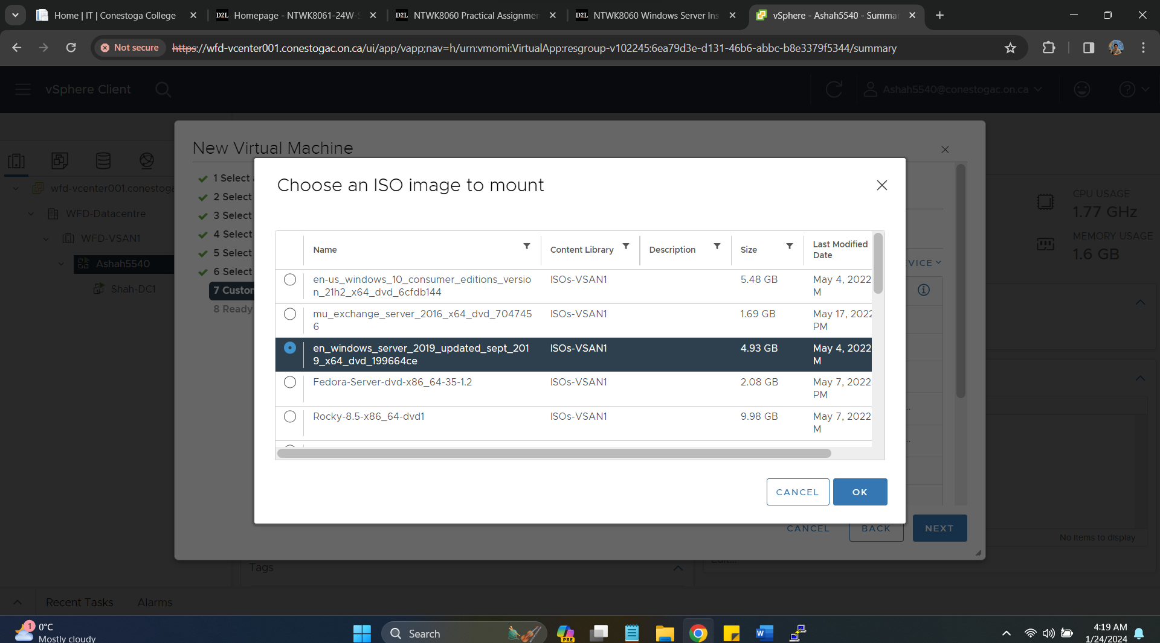 Summary of Virtual Machine installation for DC-2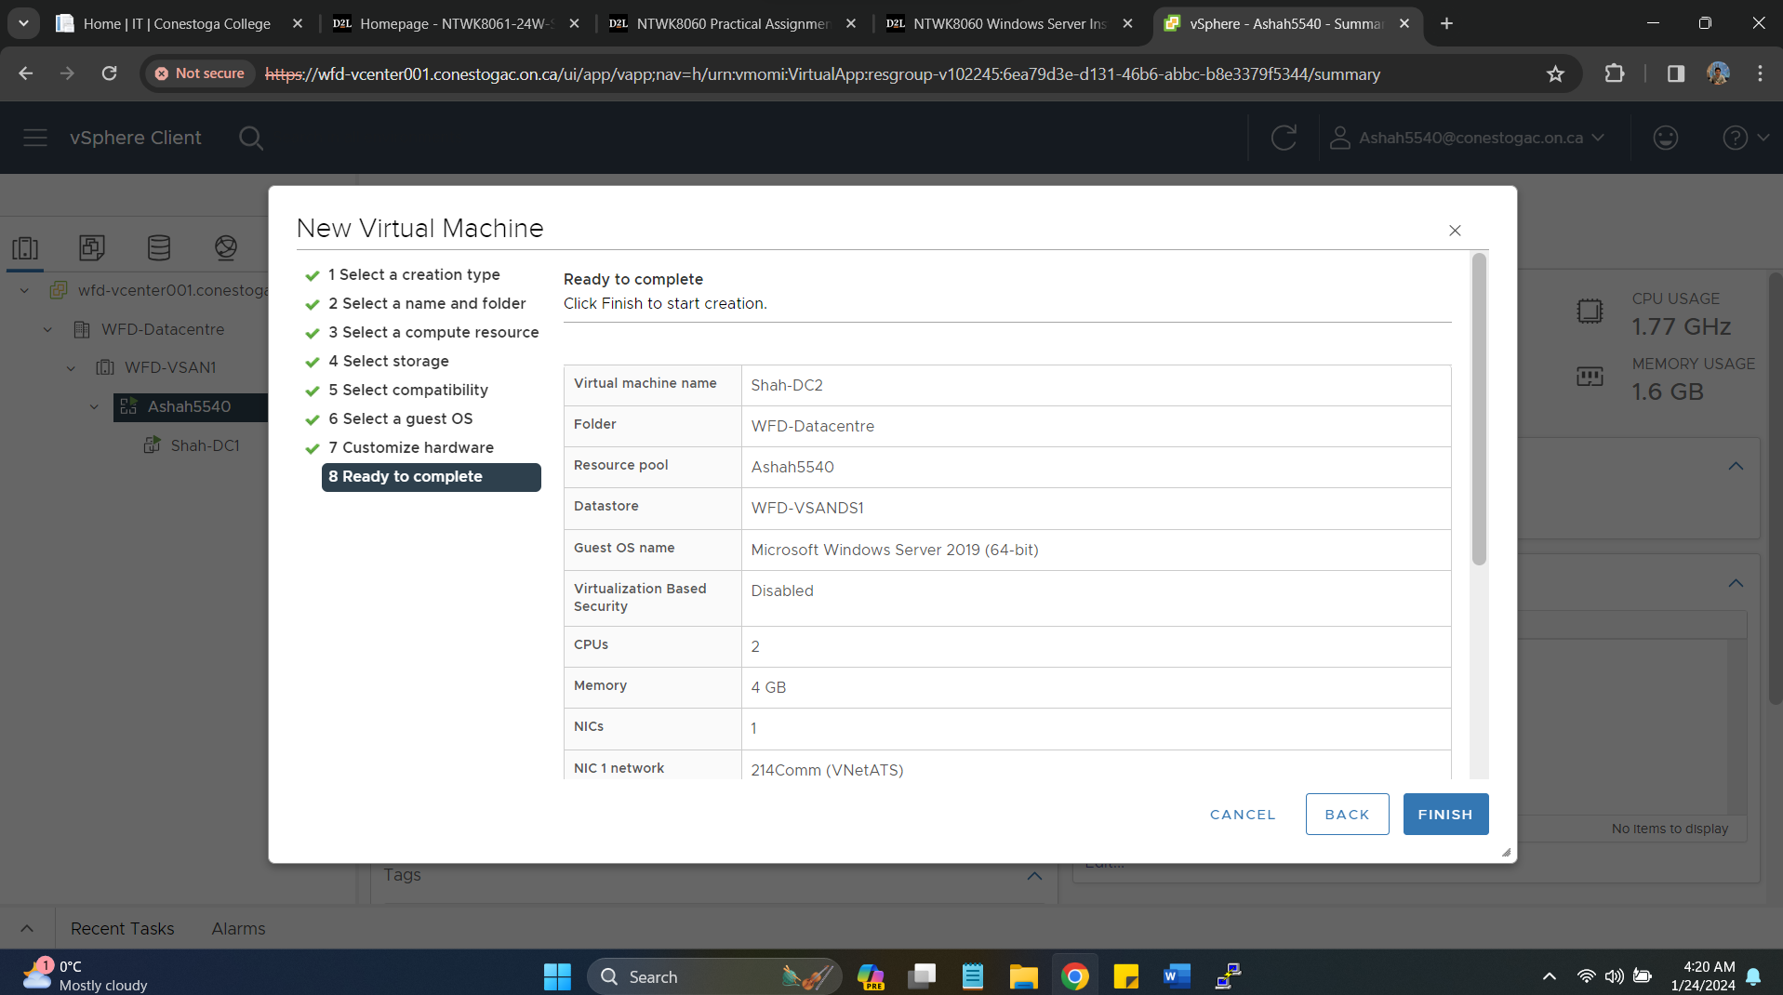 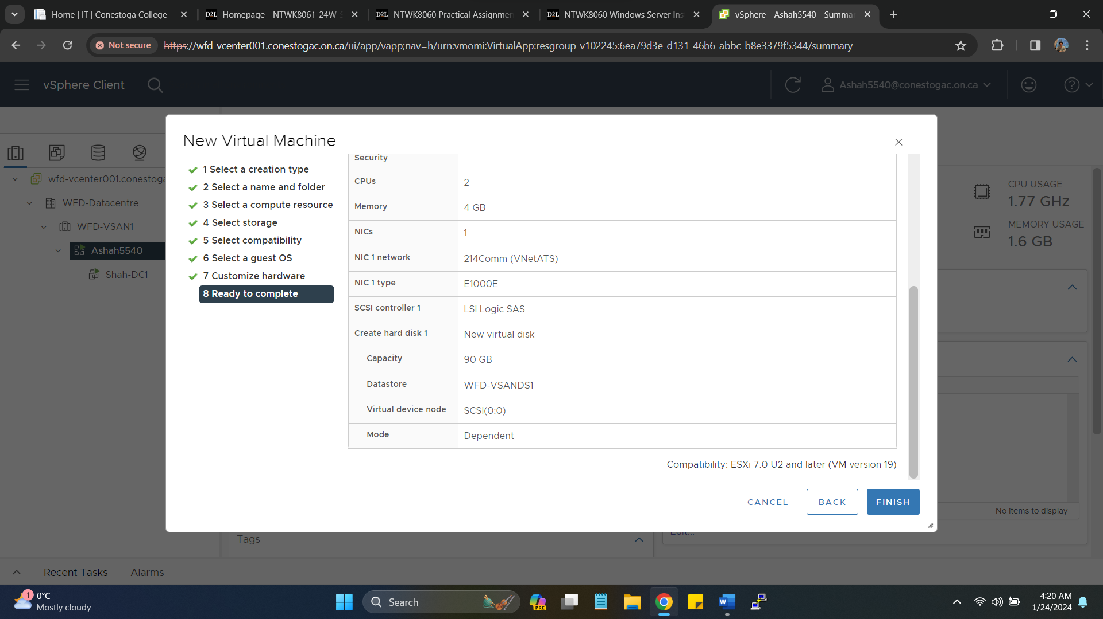Selecting Windows Server 2019 standard desktop experience for DC-2 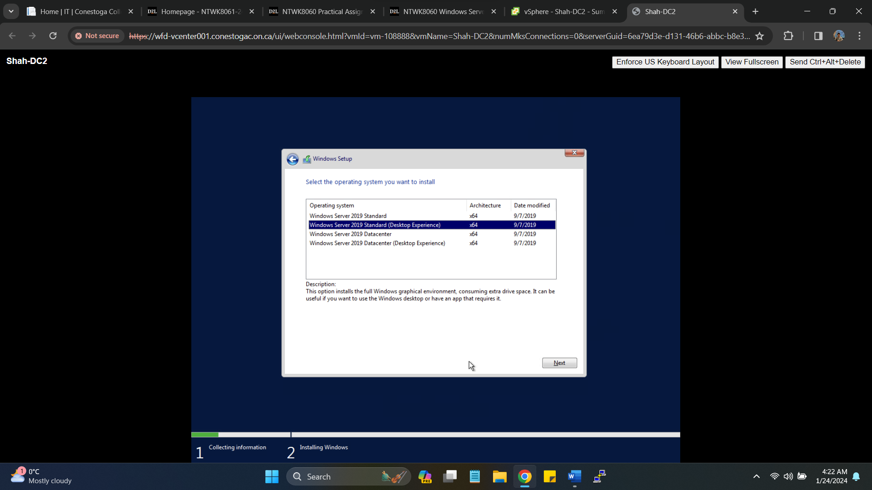Providing IP to new DC-2 (172.16.214.4), DNS pointing to DC-1 (172.16.214.3)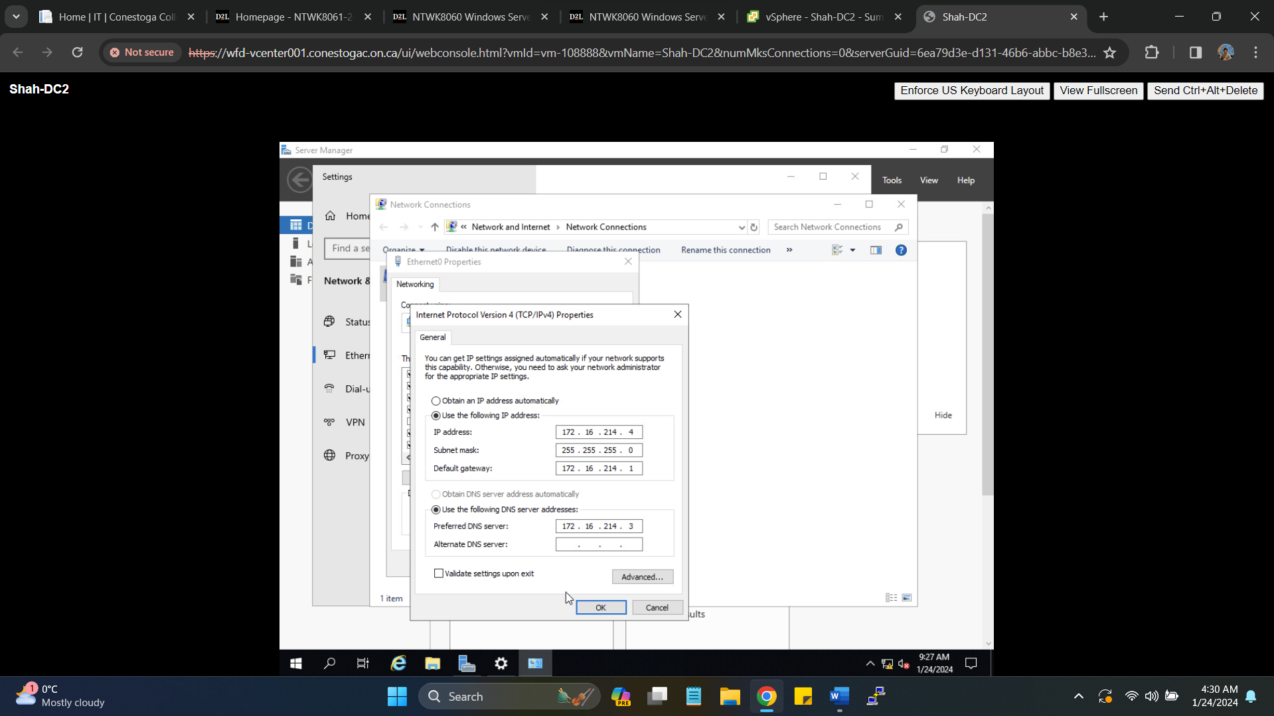Selecting Shah-DC2 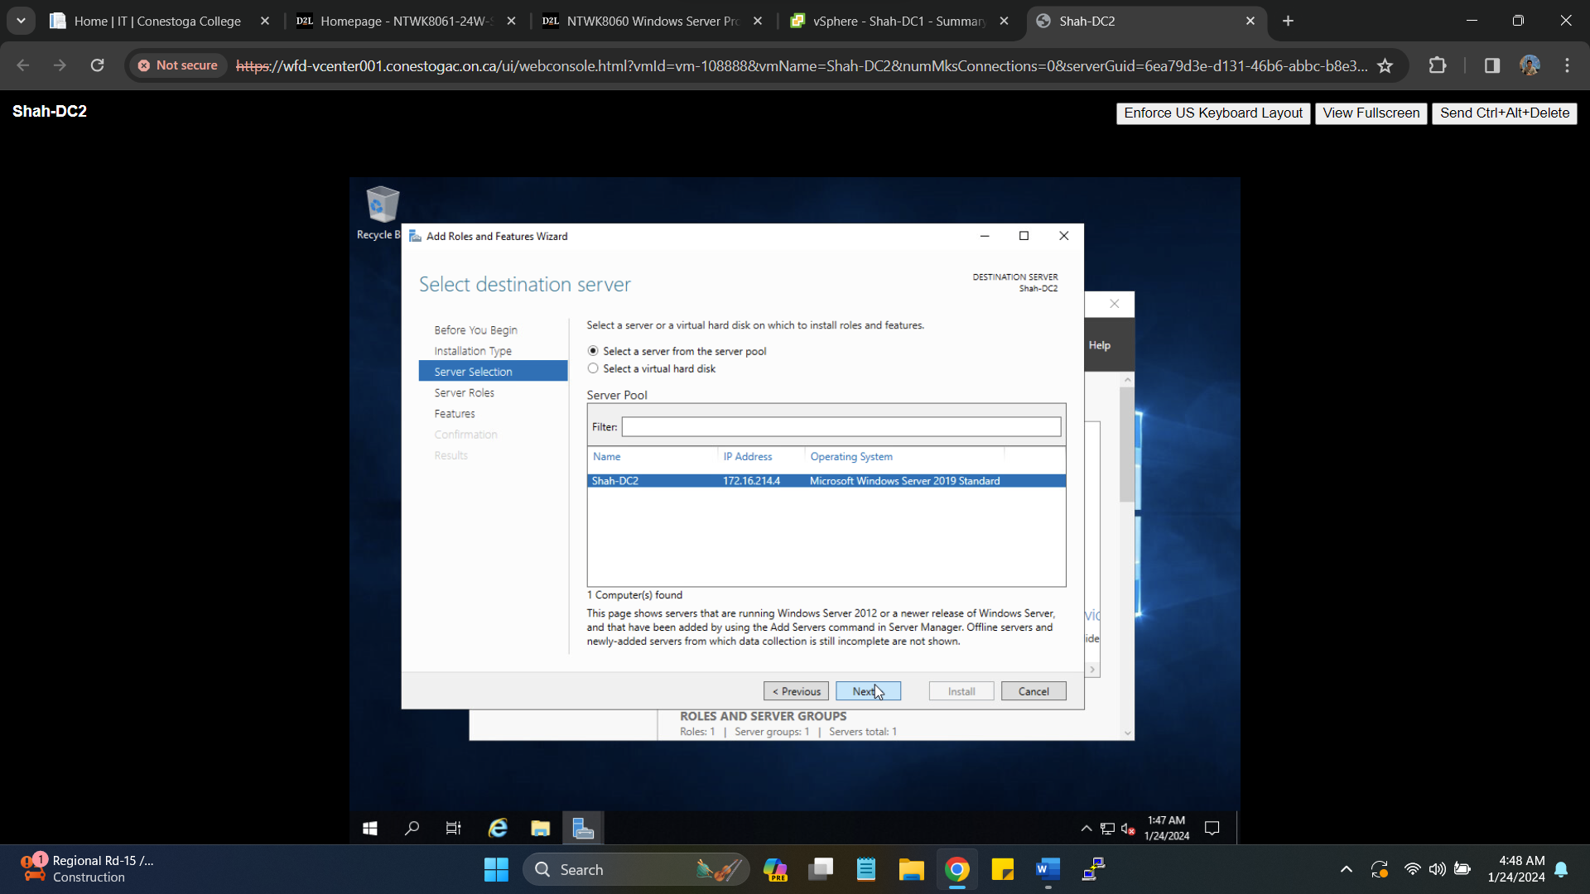Promoting Server to ADDS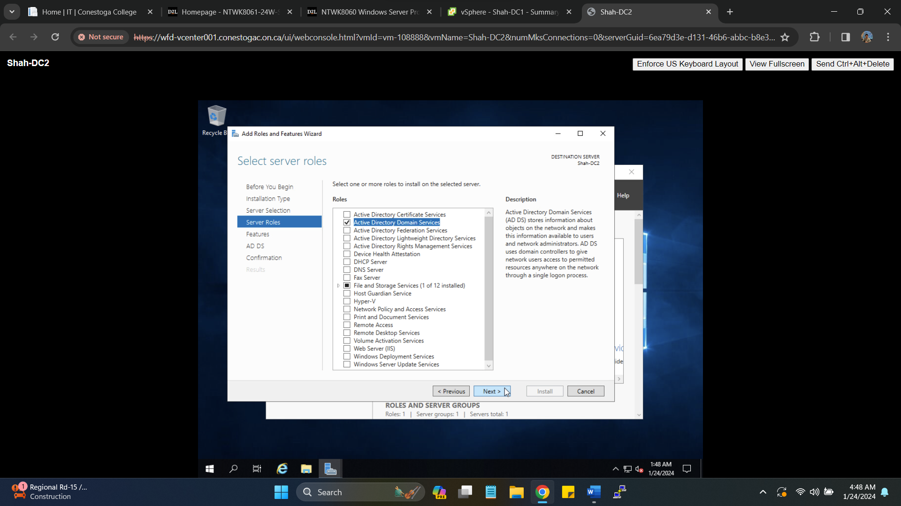Successfully promoting server as secondary Domain controller with ADDS features installed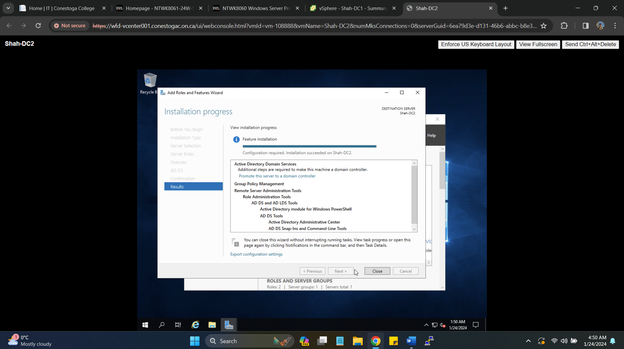Providing credentials for deployment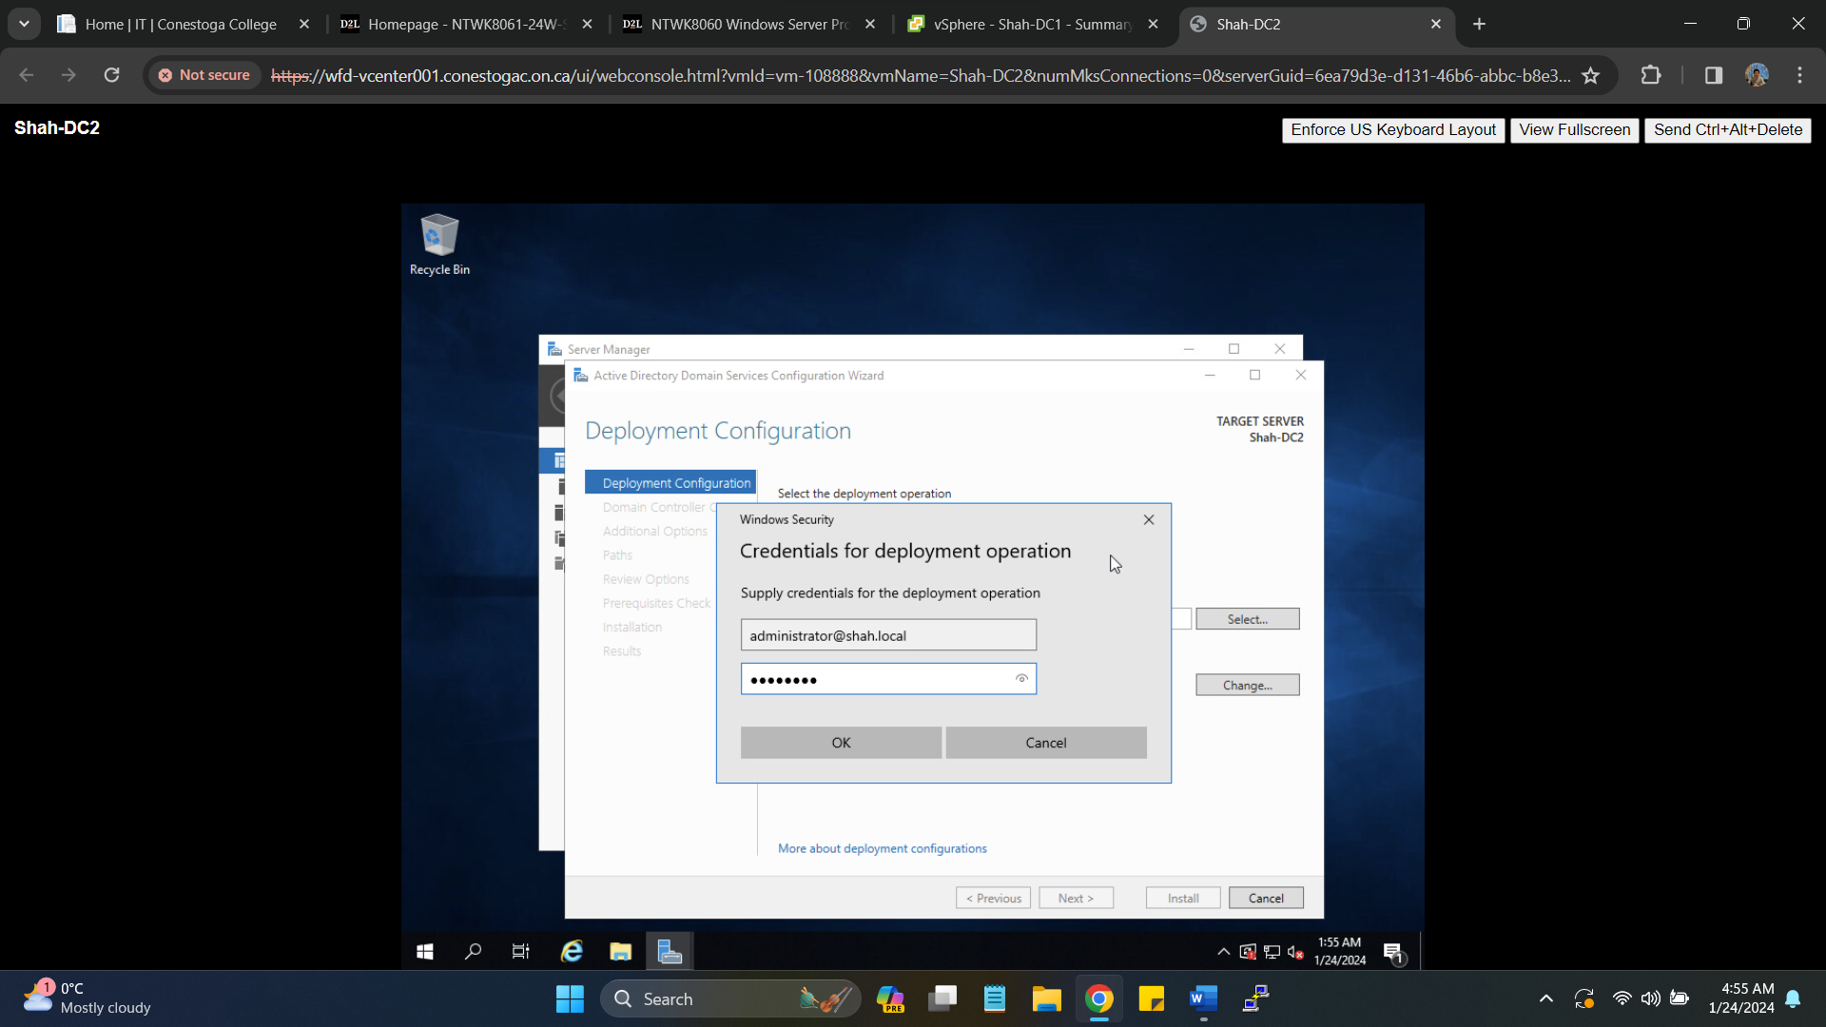 Joining existing forest domain (Shah.Local) 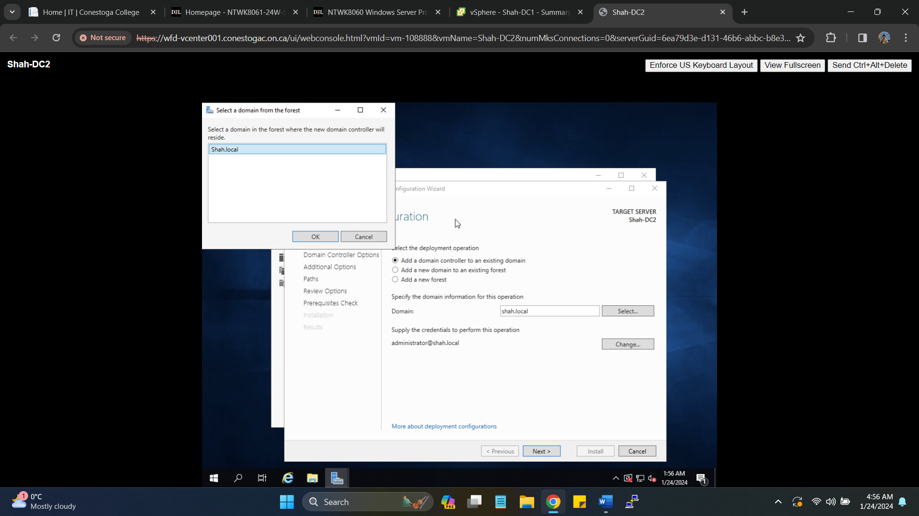Providing Credentials for DC2 (**Secret55**)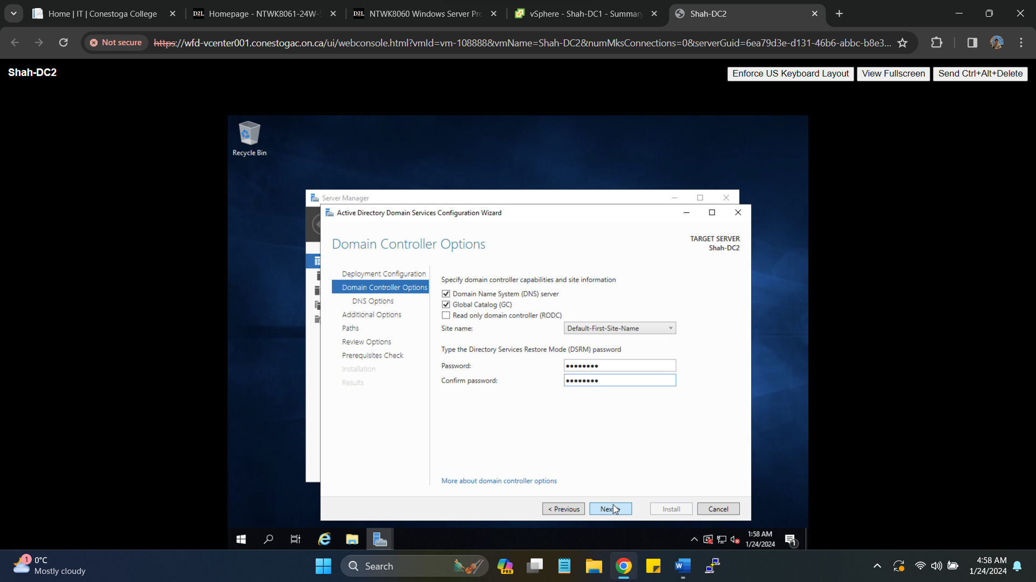Summary of Domain controller installation

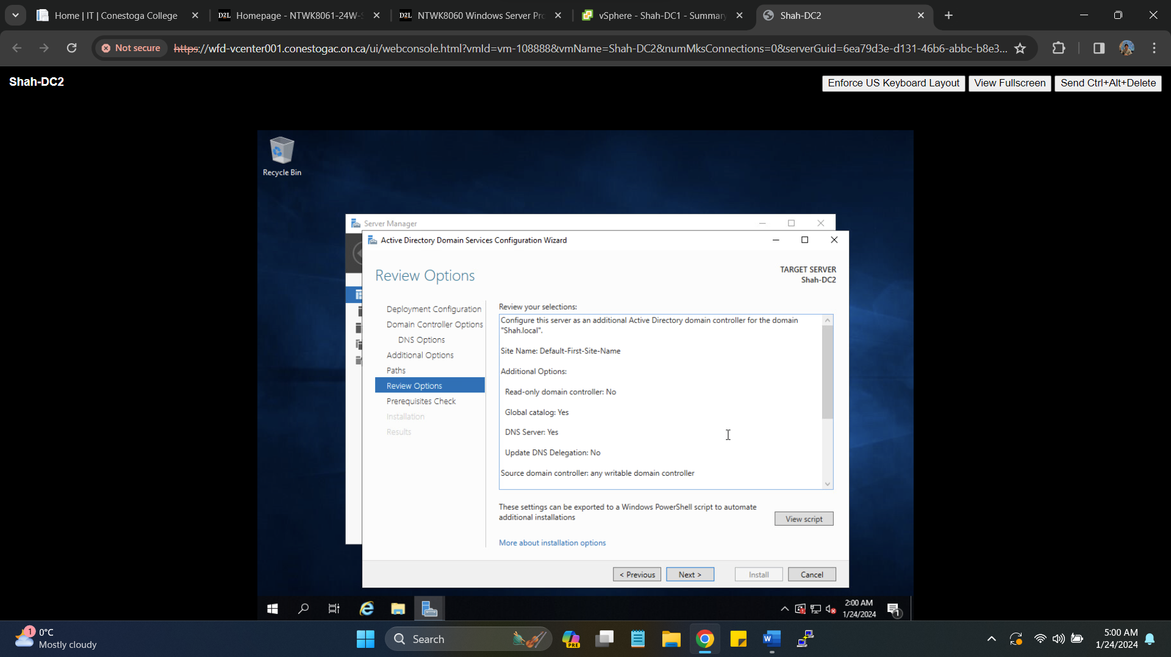Successful installation of Domain controller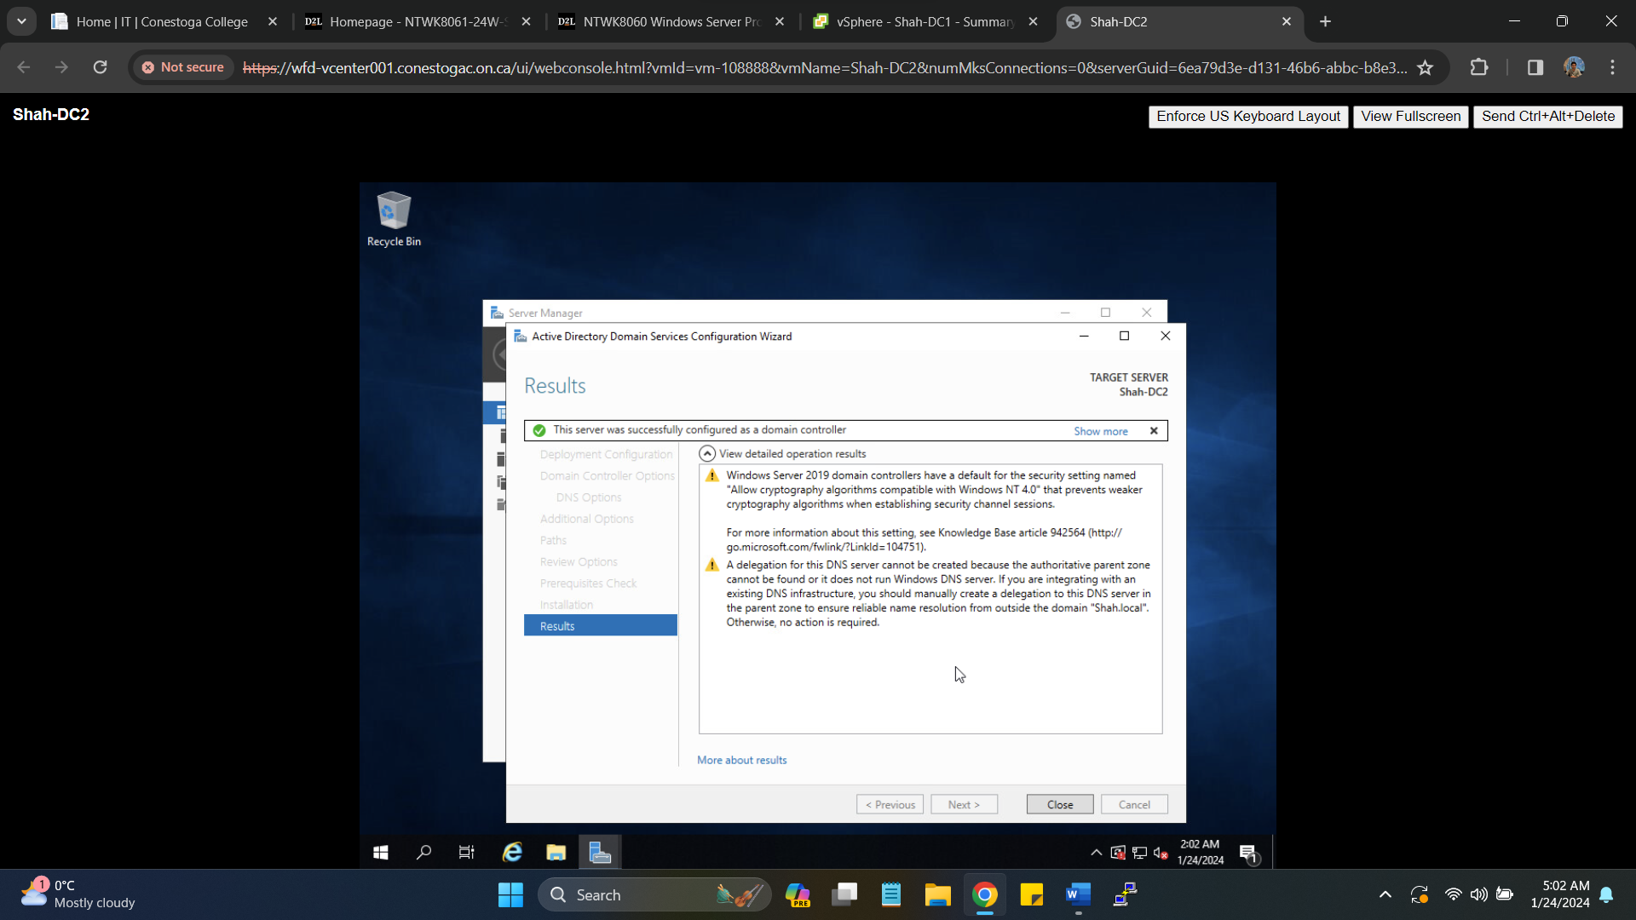Snapshot of DC-2 joining Domain (Shah.local)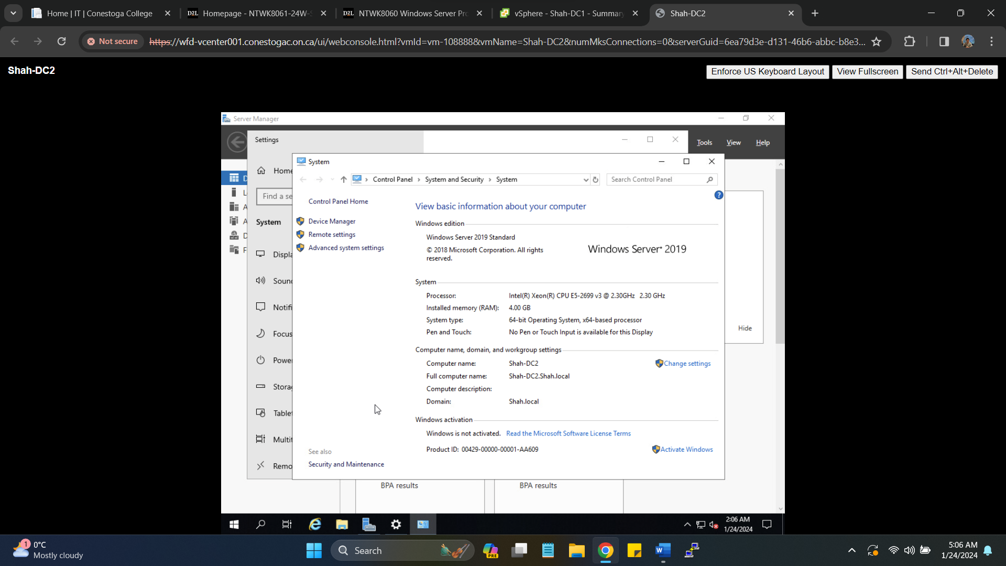Successful installation of VMtools on DC-2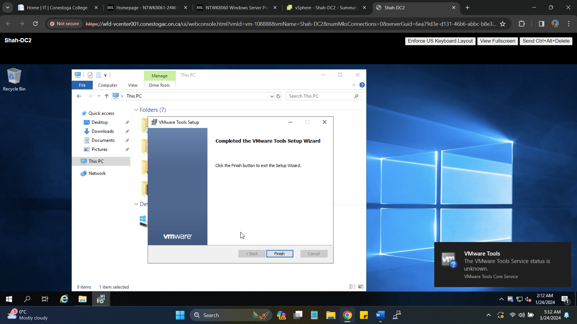

1. **Install a third Windows Server and add it as a member server in your active directory Domain**

* Set an IP address and DNS address (pointing to your DC1) in your COM port range.

Member Server (3rd Windows Server) IP: **172.16.214.5**

New VM installation for member server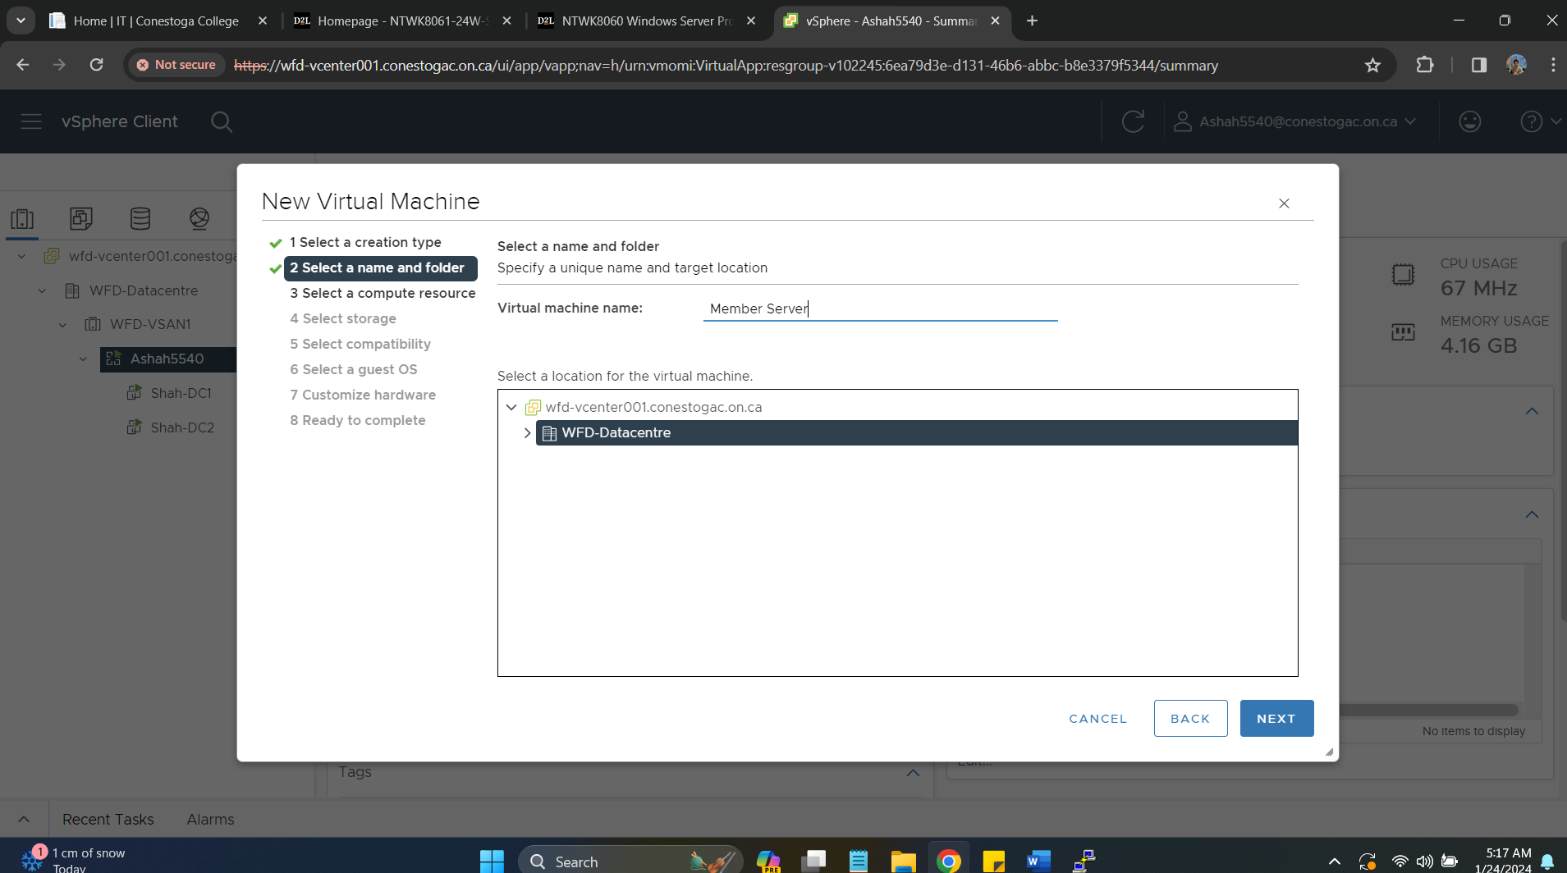

Selecting Operating System as Windows server 2019 64 bit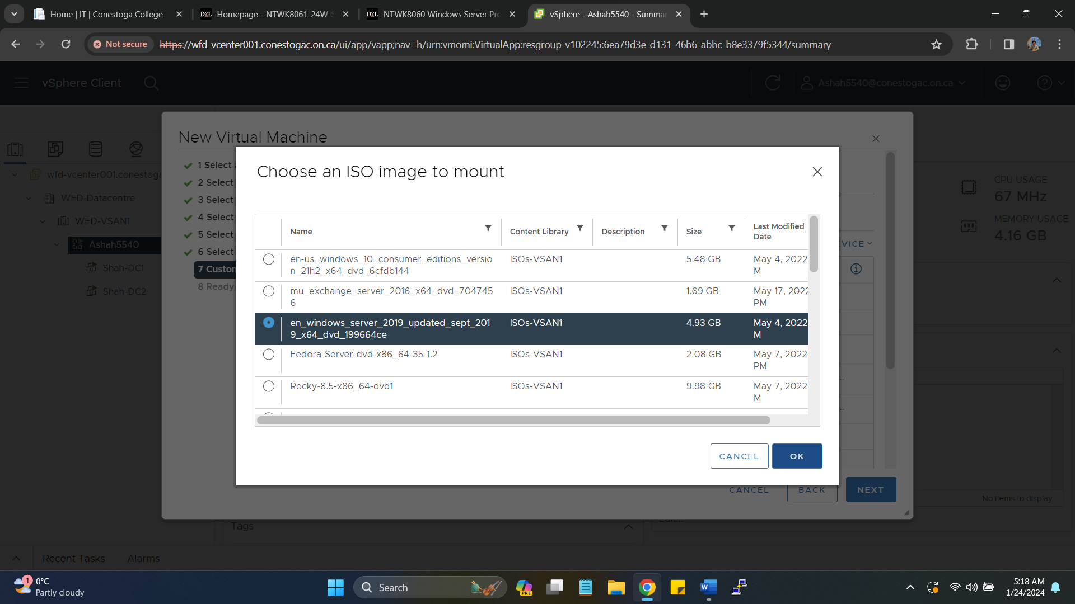Summary of VM installation for member server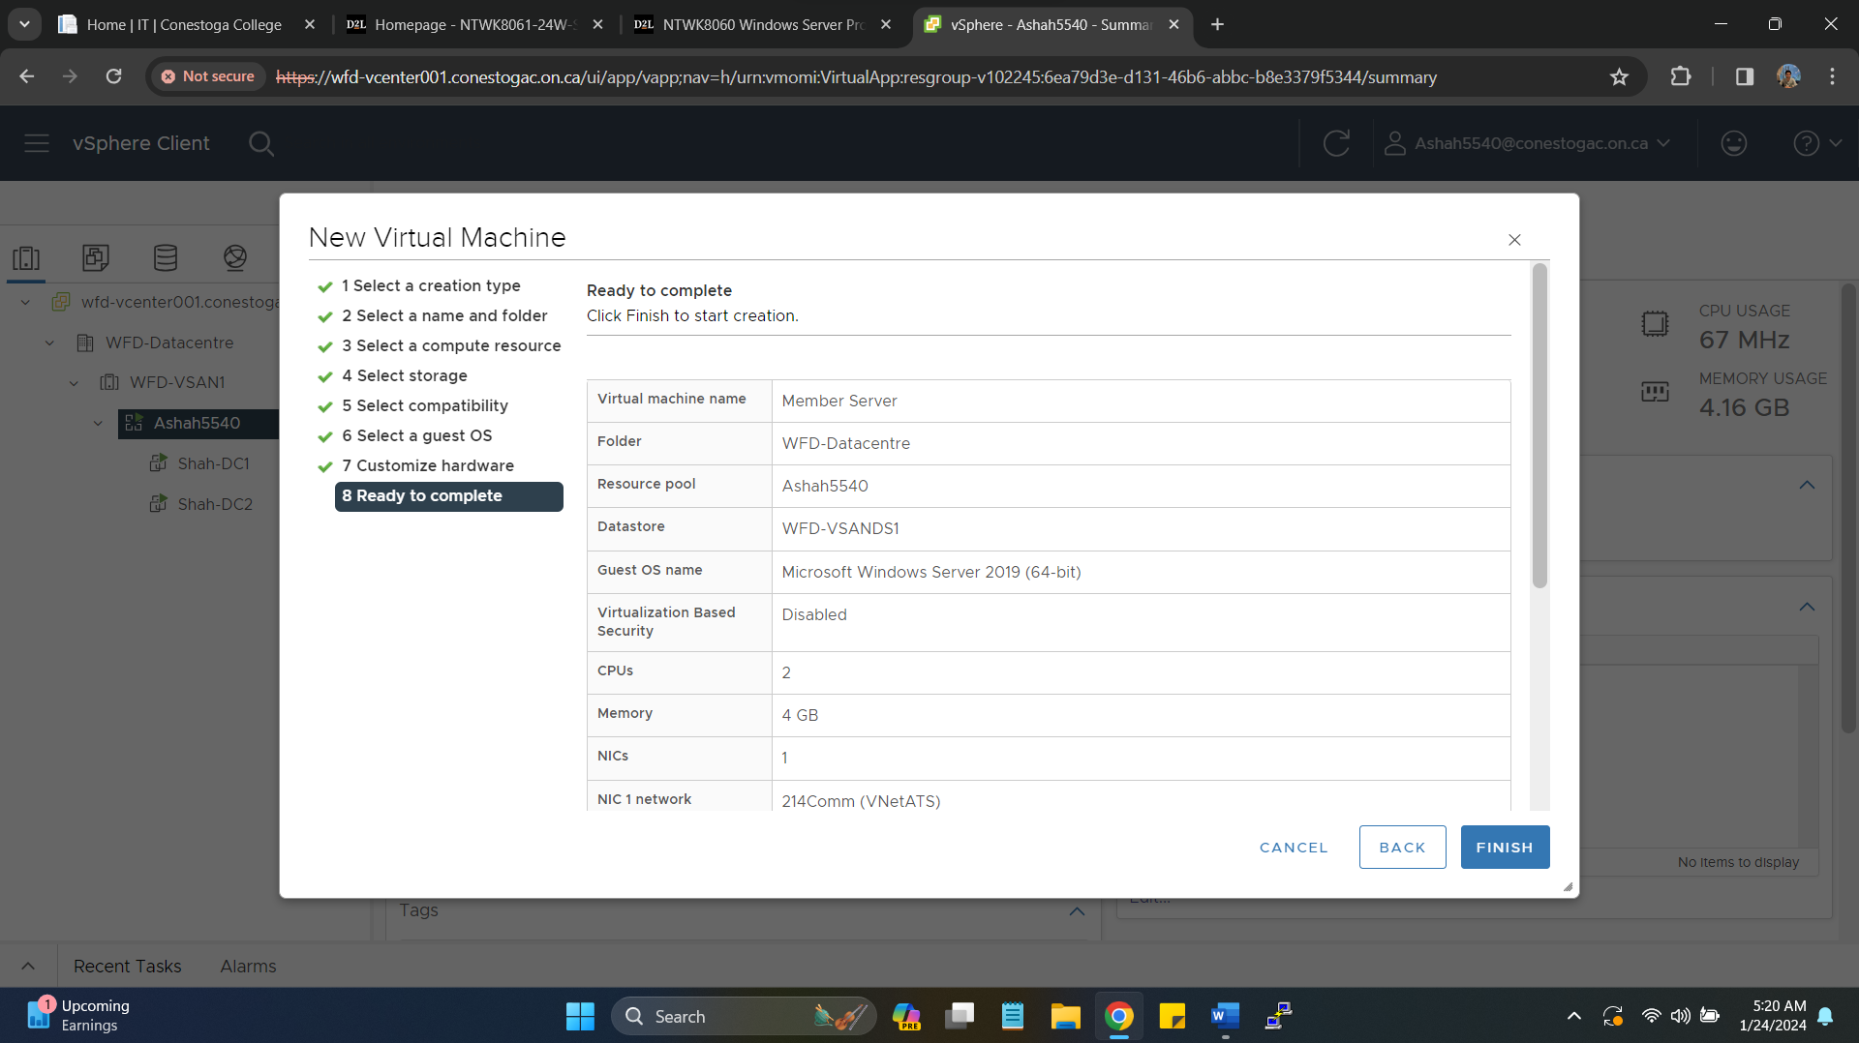Selecting OS as Windows server 2019 standard desktop experience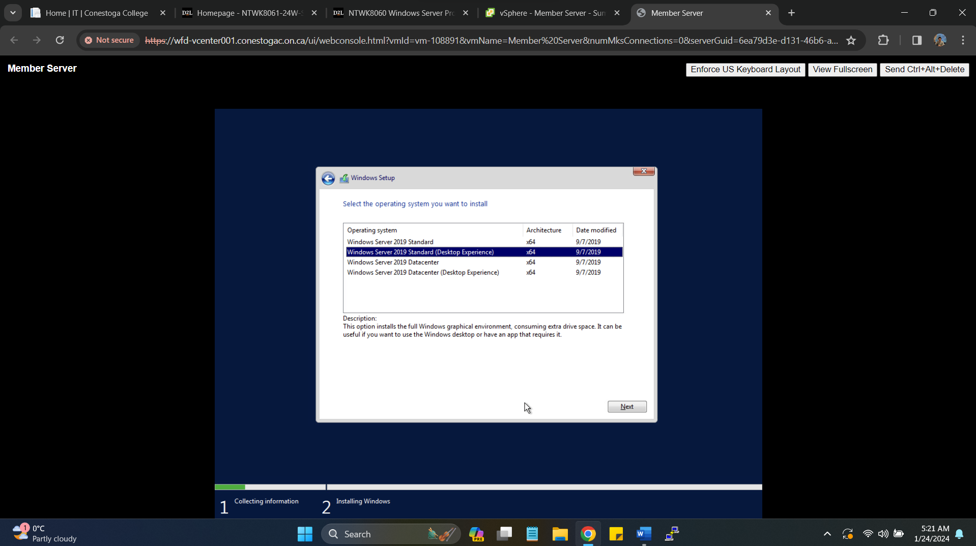Summary of VM installation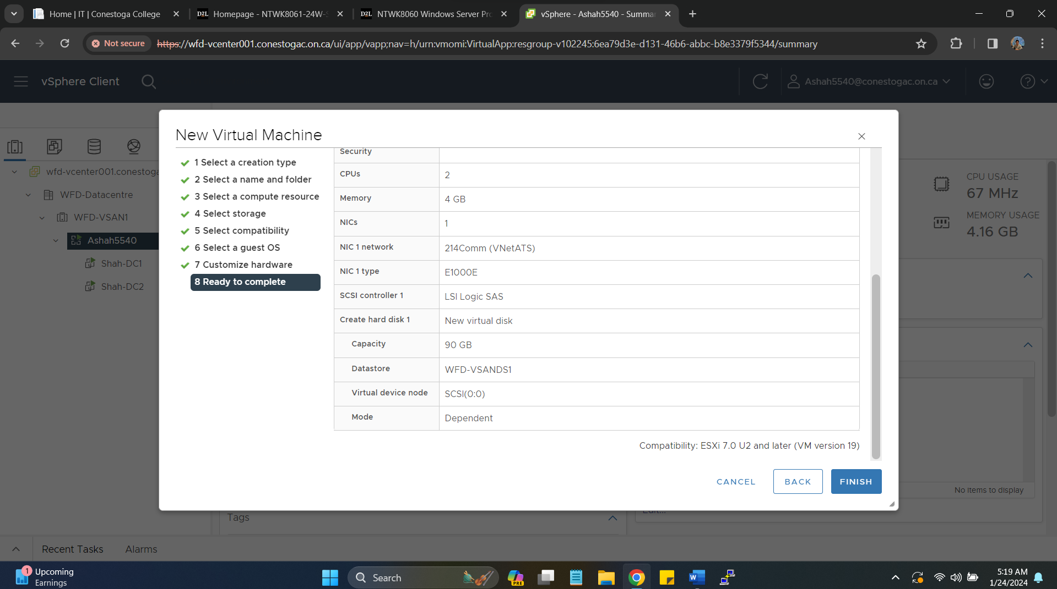Successful installation of VMtools on 3rd Windows server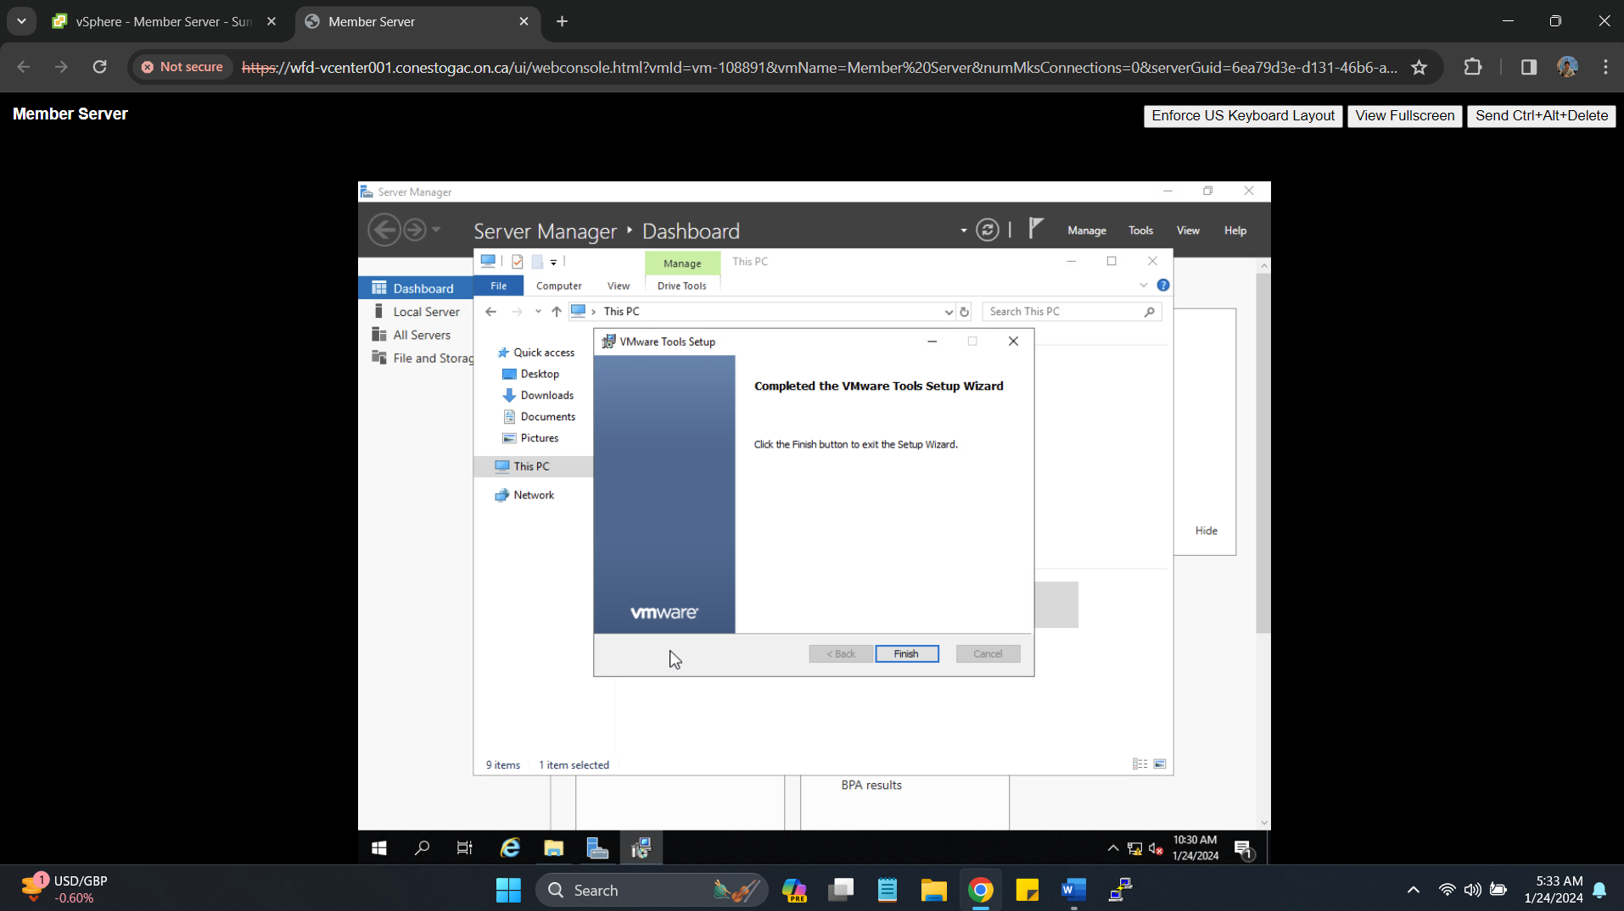Configuring IP for member server (172.16.214.5) pointing to DNS server to DC-1 172.16.214.3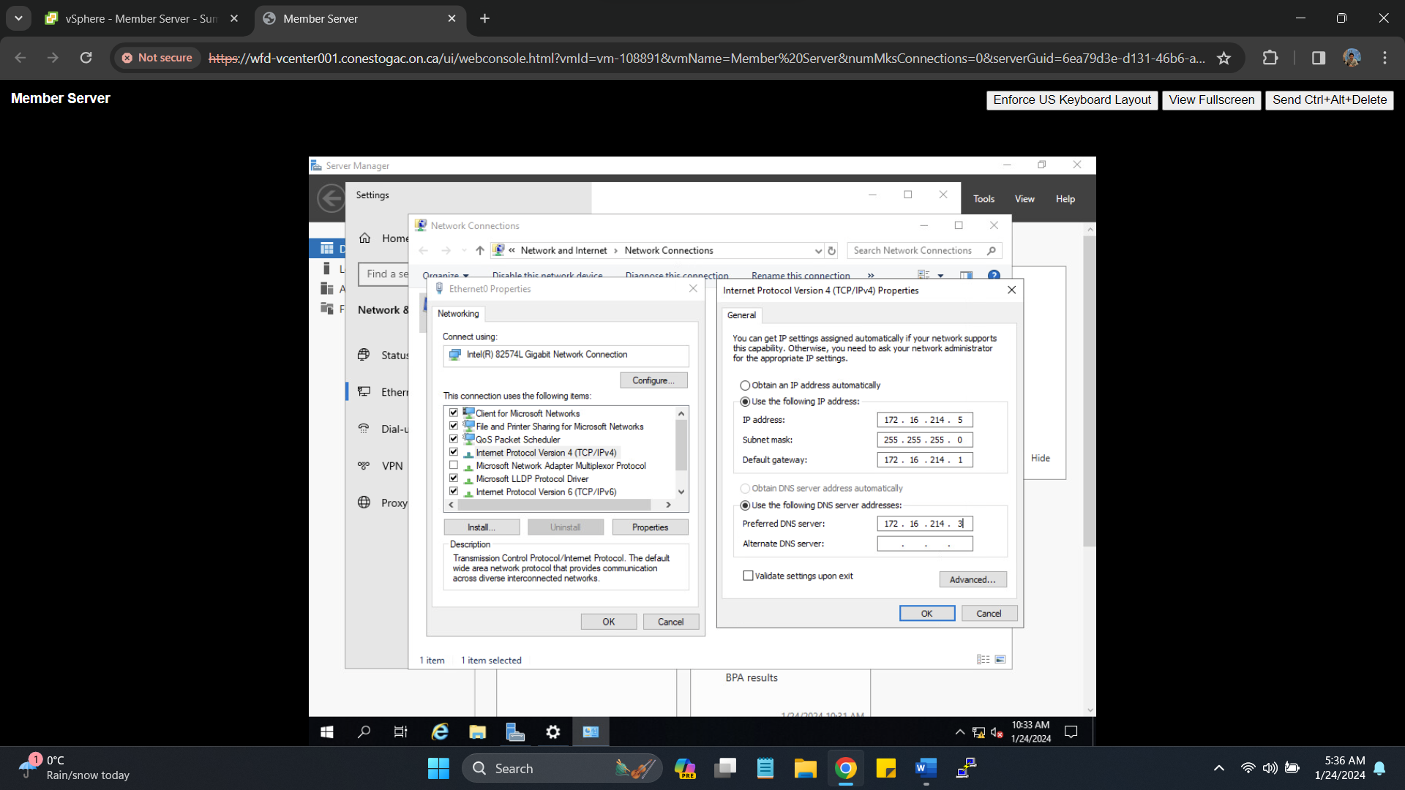Joining Domain with providing credentials and changing server name as member server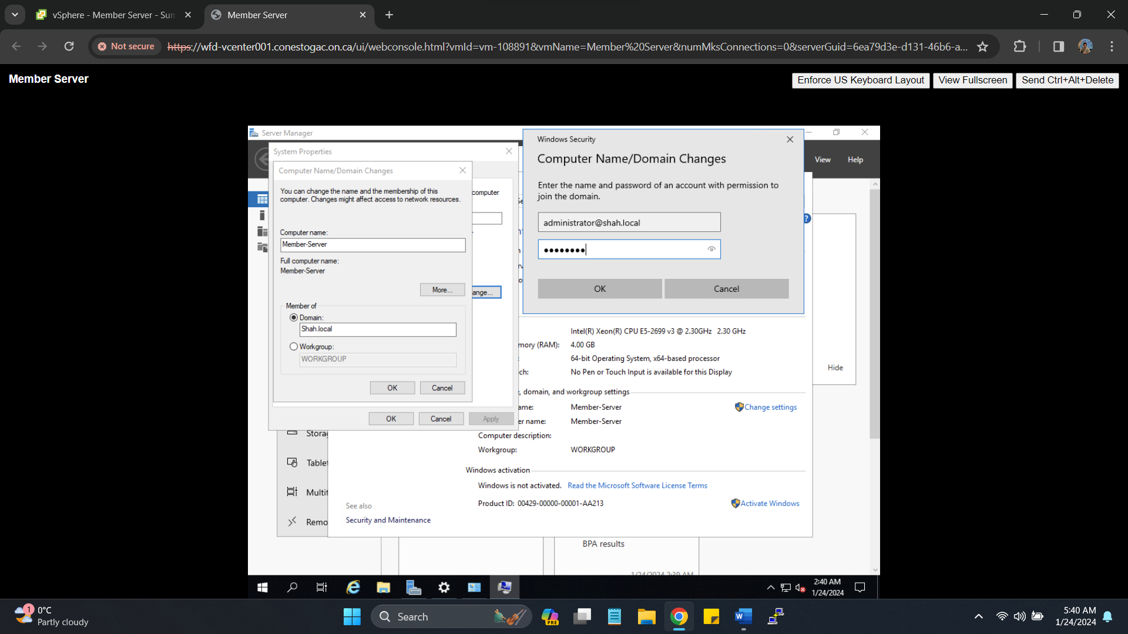Successfully joining Domain (Shah.local)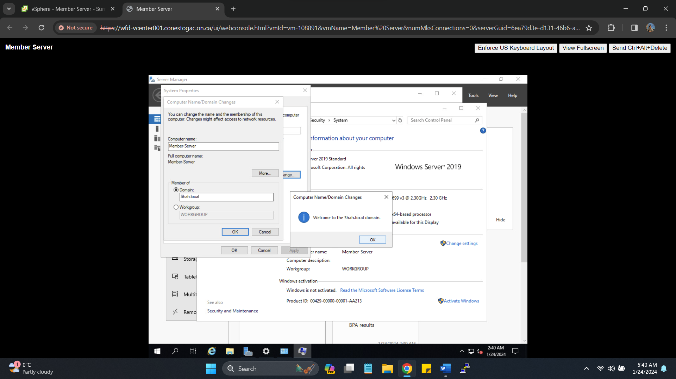Member server joined Domain summary snapshot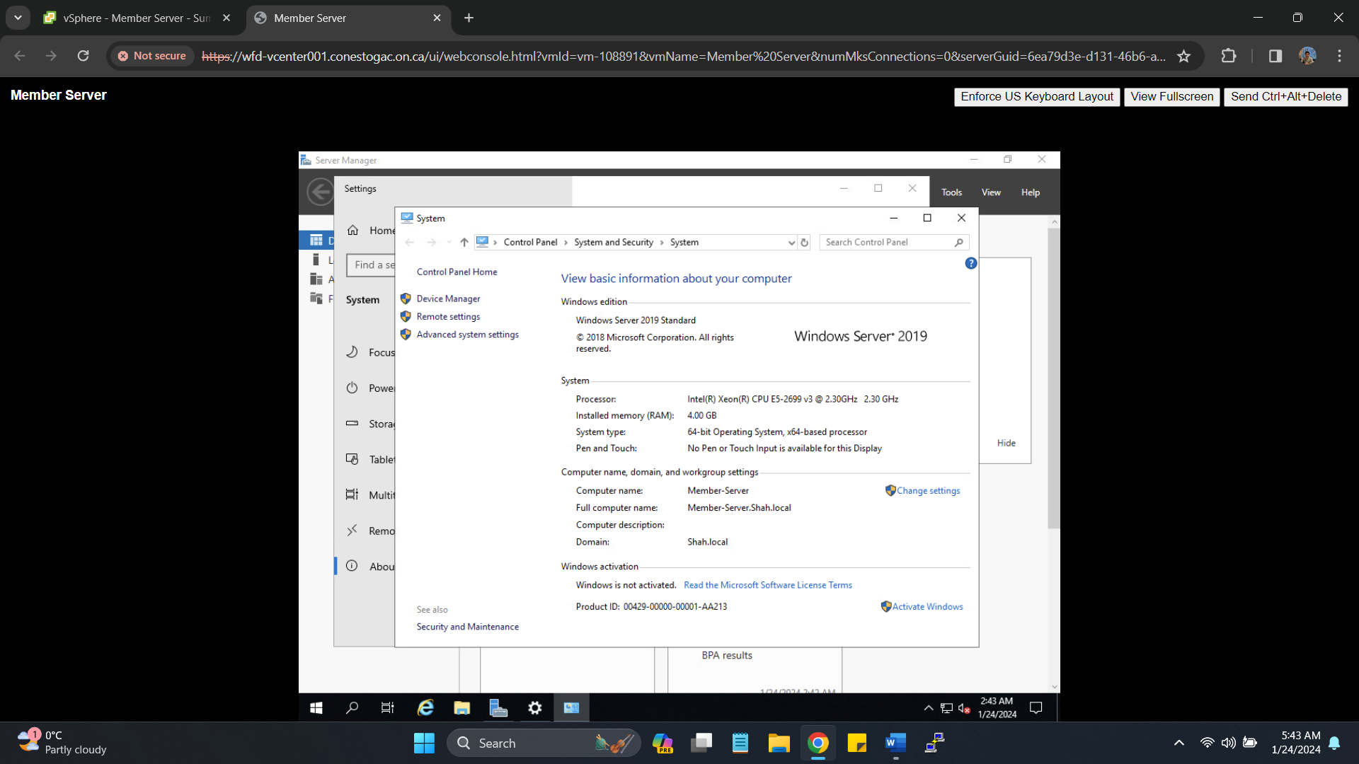

1. **Install a Windows workstation and add it to your Active Directory Domain**

* Set an IP address and DNS address (pointing to your DC1) in your COM port range.

Workstation IP: **172.16.214.6** naming as **Shah-S1**

Creating new VM to host windows 10 OS workstation, later VM renamed to Shah-S1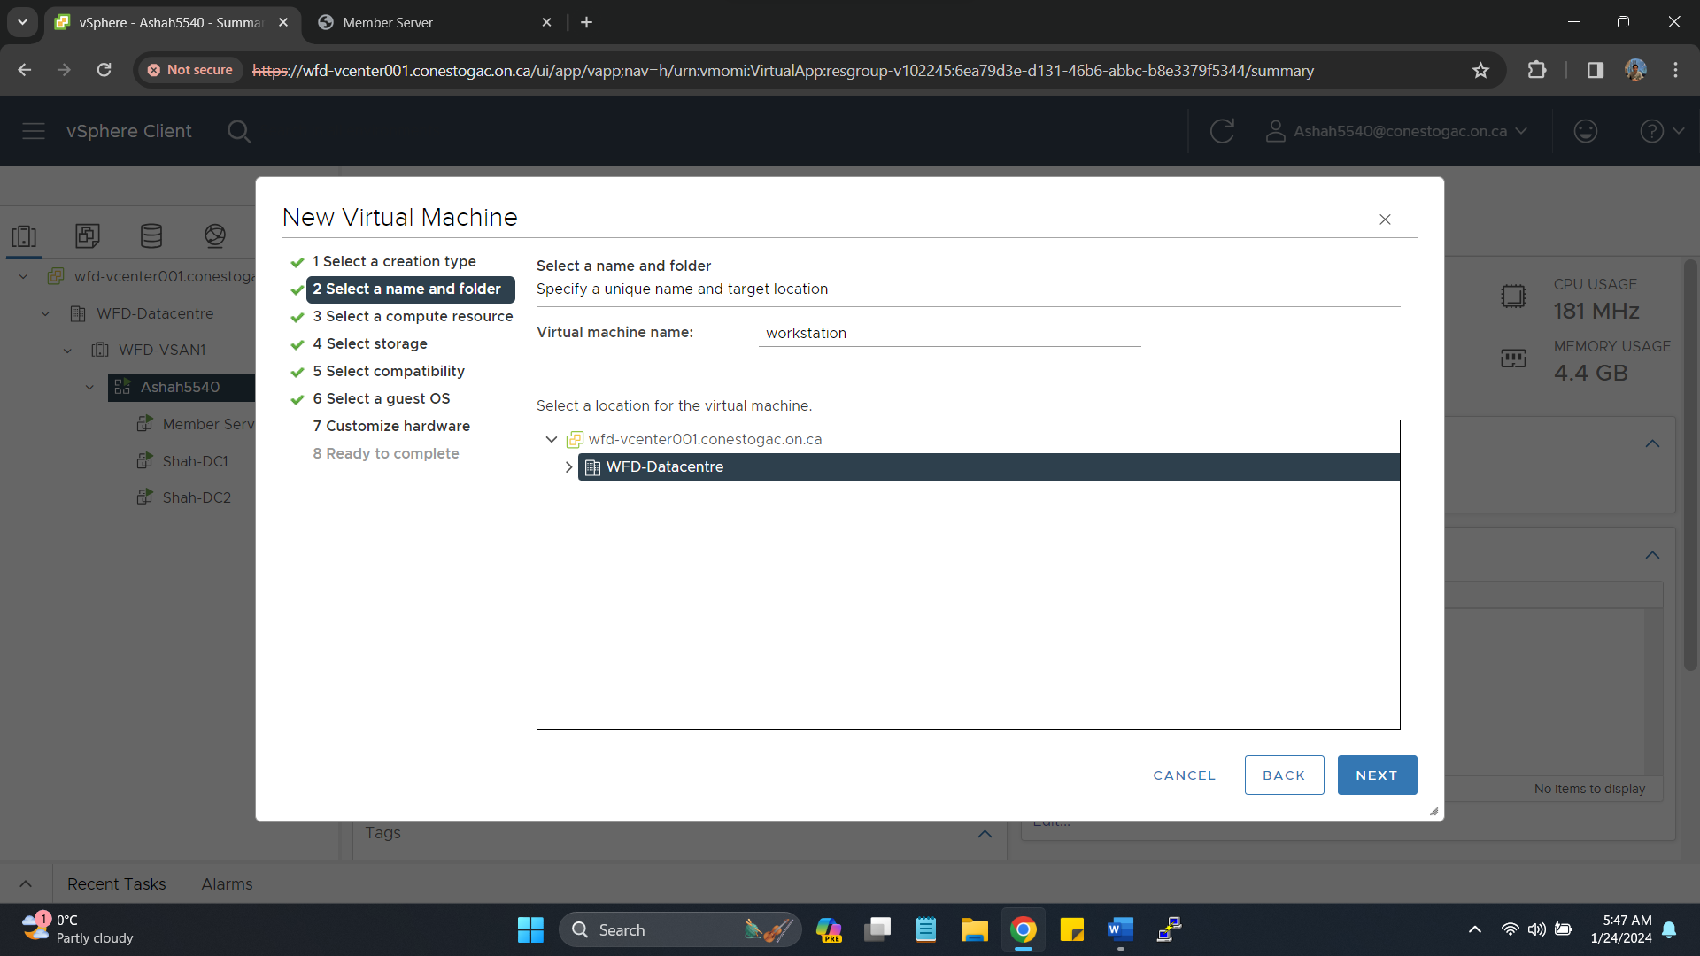

Selecting Windows 10 Operating system for installation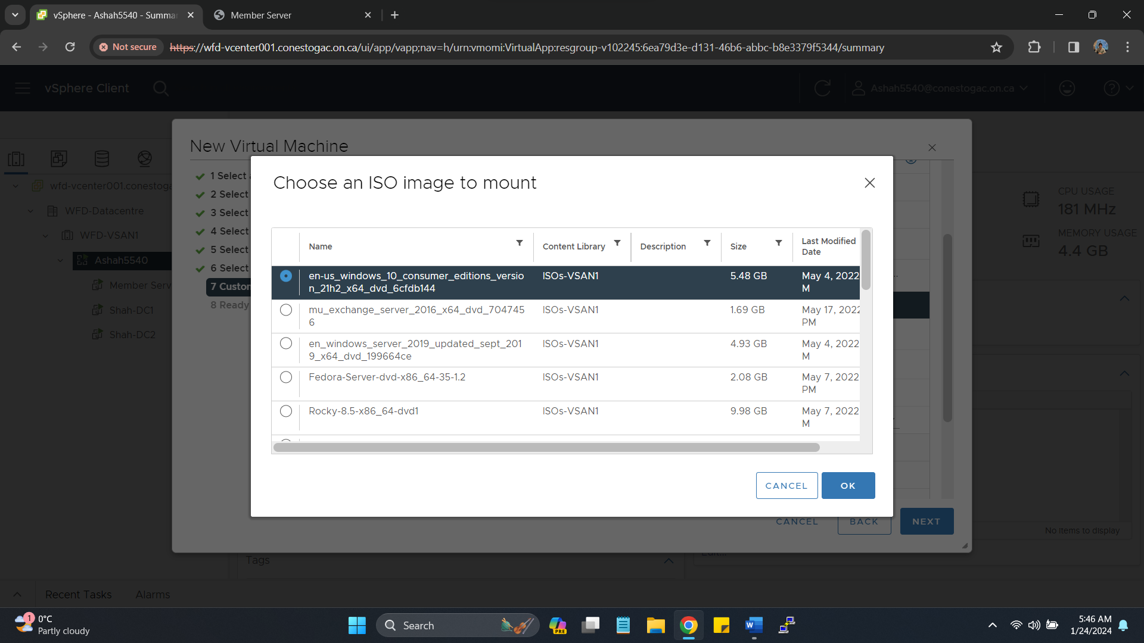Windows 10 Pro version for installation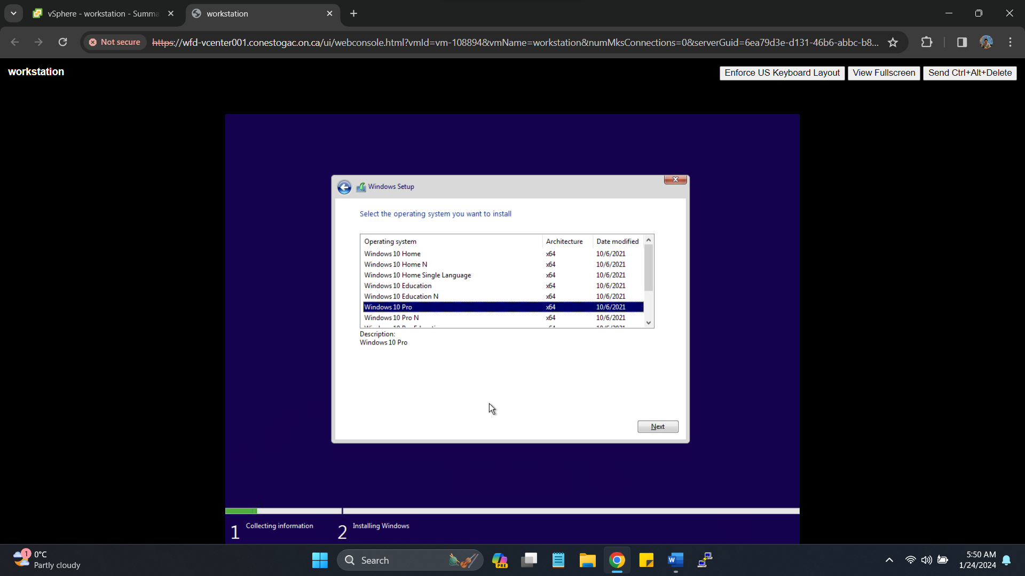Successful Installation of VMtools on workstation.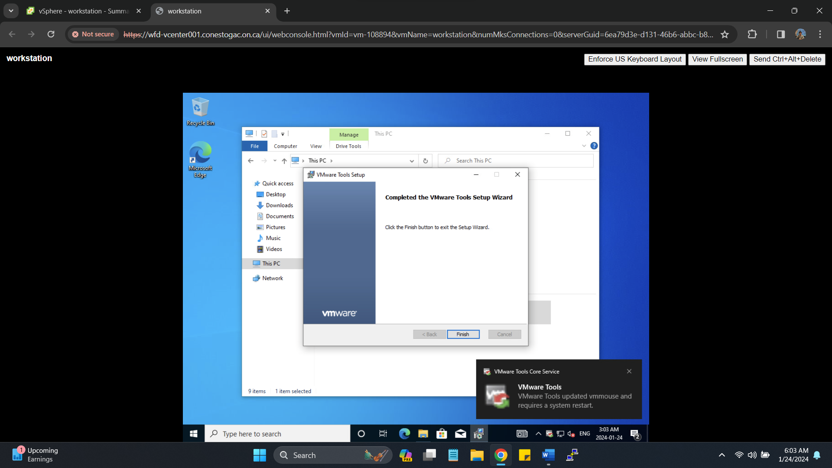Providing IP **172.16.214.6** and **pointing DNS to DC-1 (172.16.214.3)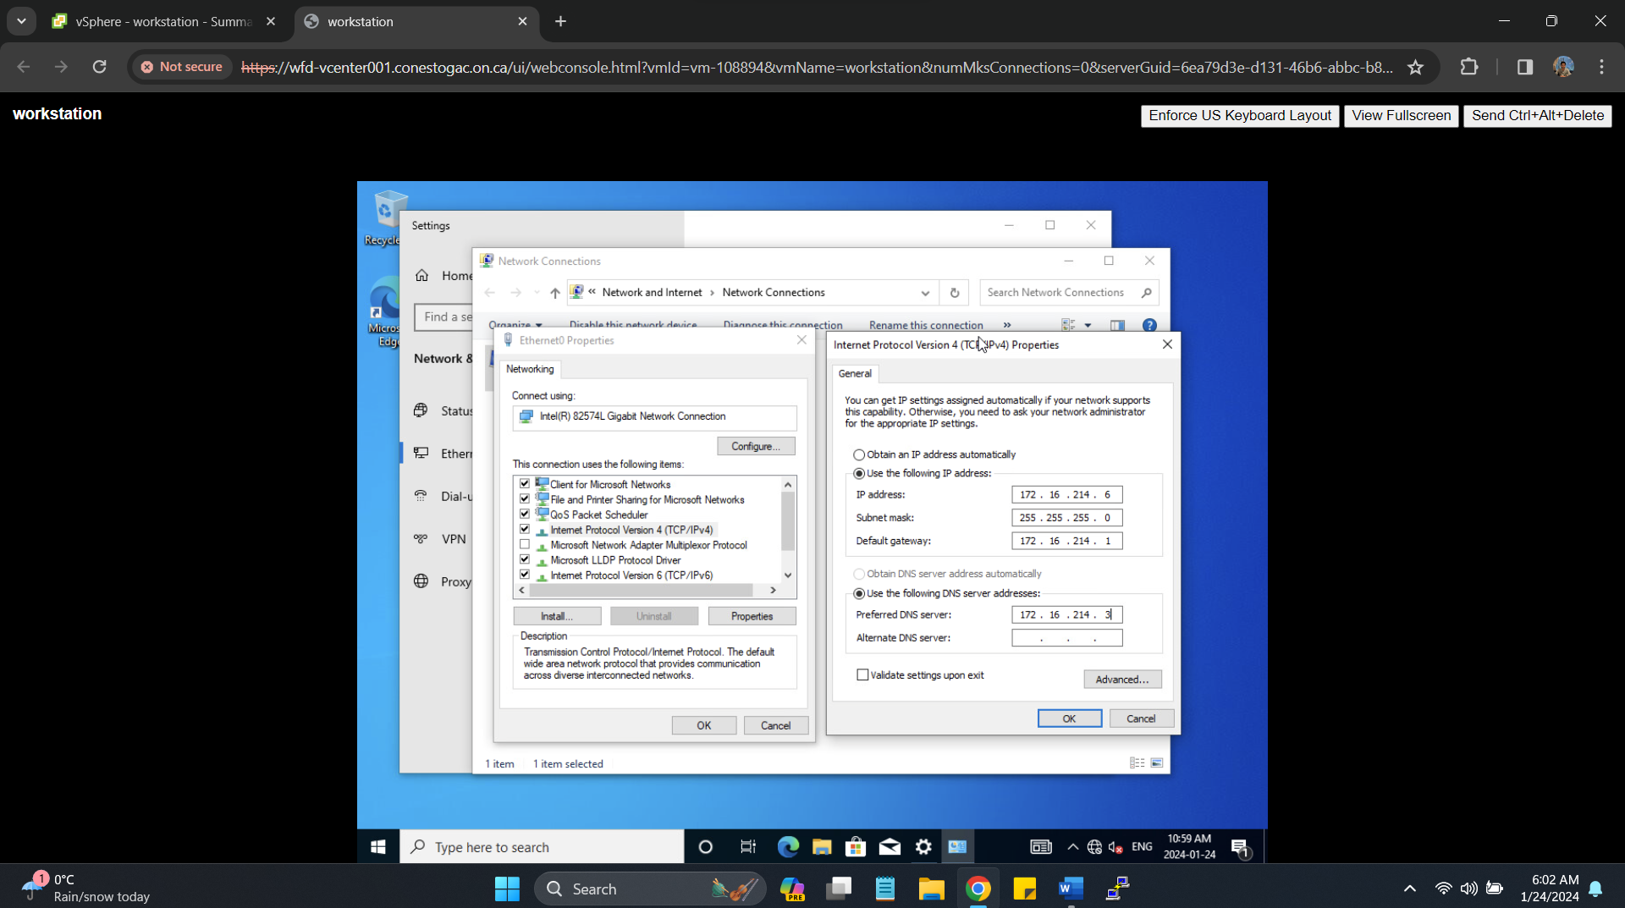Providing Credentials to join Domain (Shah.local)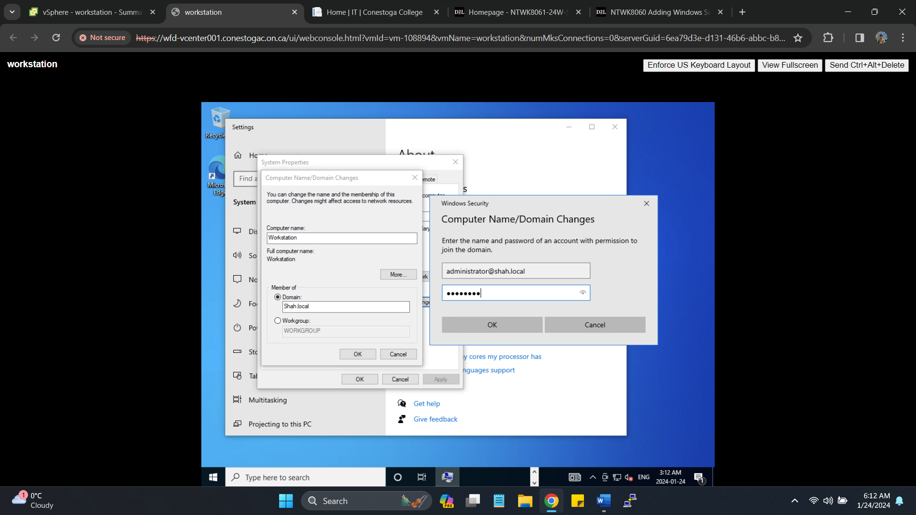Successfully Joining the domain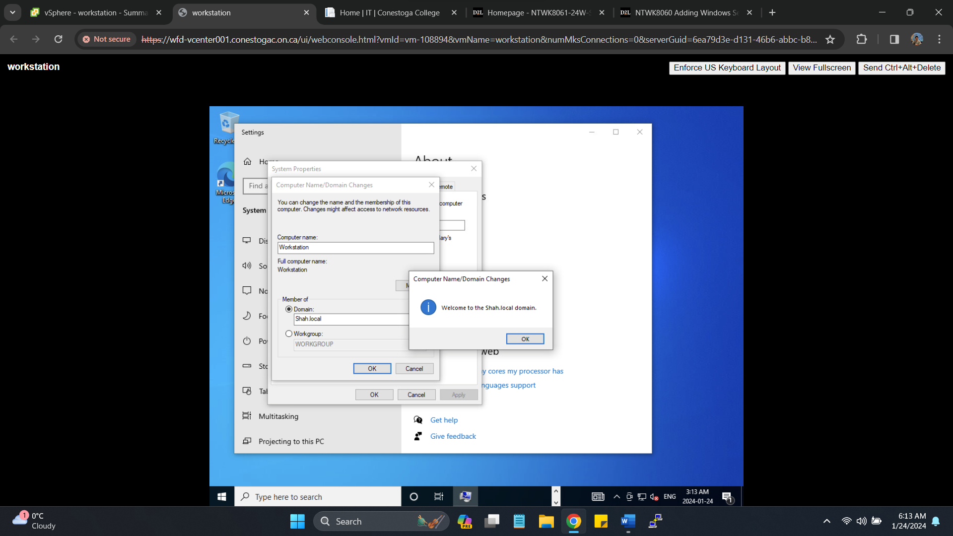Summary of workstation (Shah-S1) joined the domain.**